Os Companheiros Do Mestre

Vol.I

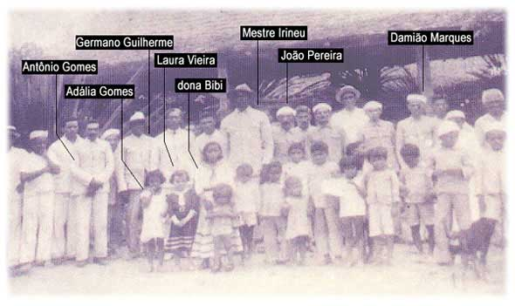

Germano Guillherme

&

Antônio Gomes

From A Familia Juramidam.com:
“From Germano, what really draws attention in his history is perhaps the friendship cultivated with Mestre Irineu. And indeed, it was through the meeting of these two migrants from the Northeast, and Germano have known the "drink of the vine" from the hands of Mestre, that later on the community witnesses’ one of the most beautiful friendships of the doctrine, mentioned by every follower and which would last until his death, in 1964.
As reported Mrs. Cecilia -- the wife of Germano Guilherme -- it was on their time off from the Guard that they often ventured in the forest to take ayahuasca. Daniel Serra, Mestre’s nephew, also tells us that in one of these expeditions to tribes across Acre’s boarders to take the drink -- during a territorial dispute between Peru and Bolivia, presumably in the late 20’s -- Mestre Irineu told him that he and Germano encountered a Peruvian patrol. In the fight that followed Mestre was even shot in the hand. And perhaps it was for this and other adventures that the strong partnership between the two friends lasted until the end.
About the hinário of Germano Guilherme, one might even say it’s a true narration of the incredible universe of Irineu Serra, his beloved Mestre, and this way being the one that first presented his verbal imagery on the physical plane.

__________
The Divine Eternal Father
Came and formed His world
Came and formed His world
And lived and dwelled
With all of creation
With all of creation
With Your love
He left and carried
And so distant he remained
And so distant he remained
Looking upon His creation
Looking upon His creation
With your brilliance of love
With Your brilliance
With your brilliance of love.
***
About his origin and his life, the first comprehensive research done on Germano Guilherme comes from the site www.hinarios.blogspot.com, which says:
Germano Guilherme dos Santos was born in Piauí, in May 28th of 1902. He moved with his family to Rio Branco, Acre, where he lived working in the colonies. When serving in the Territorial Guard, Germano met Raimundo Irineu Serra, as well as he met the Daime through this friend. He was not only one of Irineu’s first followers, accompanying him since 1928, but was the first to sing a hymn in the doctrine, even though the first hymn was received by Mestre, two decades before, in the Peruvian jungle (1912). Therefore, it is a tradition in Alto Santo to sing his hinário before the “O Cruzeiro”.
Germano Guilherme was a man of black skin and pristine teeth, having great fondness for Mestre. They called each other as “little brother”. In his asking to the Daime, for the cure of a wound in the leg, he saw that in a previous incarnation he had been a cruel slave holder, thence not having a cure for the same wound because it was a “sentence”. Because of this he could not eat certain foods, but when Germano was in the house of the “little brother” he would eat everything and feel nothing.
In 1943 he married a daughter of Antônio Gomes and Mrs. Maria de Nazaré, Ms. Cecilia, twenty-six years younger than him and whose teenage son (who she had with José das Neves) had been adopted by Mestre and his wife, Mrs. Raimunda. To this child was given the name of the uncle that Mestre left in Maranhão, Paulo d'Assunção Serra. Germano Guilherme died in 1964, leaving behind his hinário “Sois Baliza” as one of the foundations of the doctrine that he helped to build together with his beloved Mestre.
Still speaking of his marriage with Mrs. Cecilia, she tells us in her account:
"This way was godfather Irineu. For me he was everything. He was my father, my master, my godfather. He raised me and I lived many years in his home (...). Then I married Germano through Mestre’s guidance. I was sixteen and Germano forty-two. But godfather Irineu saw that the marriage would be good for us. So we got married (...), always following his guidance. "[The Religions of Ayahuasca - Sandra Lucia Goulart]
Of all the accounts collected, the image built on Germano Guilherme is of a zealous person, a good companion and very firm in his work. He was known for his assertiveness and firmness in the attitudes and words. And Teófilo Maia complements:
Moreover, a tale that is told of Germano tells of a day when he was at home and a boy came and asked for two oranges from a fully loaded orange tree, which he promptly consented. Only that the boy took several oranges and put them in a bag. When he walked away, saying thanks, Germano called him back and said: “You asked me two, then pour the bag and take the two that you asked for.” Of this way it was done, and the boy was leaving a little ashamed when Germano called again. The youth, already afraid at this point, stood still. And Germano said: “Now you gather the rest and take it, because I am giving to you. And learn how to ask in order to be able to receive.” Because of this story, and others, it was reserved to Germano the nickname “buraco” [hole - which means fearless]. This history was told and witnessed by Mr. Paulo Serra, who lived with Germano and his mother, Mrs. Cecília.
In an interview to the site The Juramidam Family, Daniel Arcelino Serra, Mestre’s nephew, accounts:
“Germano Guilherme was one of the first people who helped my uncle in doctrine. He was the second person to receive hymns. I worked a lot with him, including in his house. He lived well and was a very capricious person, married to Mrs. Cecilia Gomes, sister of Mrs. Peregrina [Mestre's widow]. He had a very strong personality and was highly respected by the fraternity, for he liked everything to be neat.
He was very strict with people who worked with him, as it had to be done the way he wanted. Even to sing his hinário was necessary to have respect, and he did not like when people sang it out of the works.”
About Germano and the salão, he was renowned as an excellent singer and a maestro with the maraca, making a point of personally checking the compass and the conduction of his hinário. And Teófilo Maia finishes saying that to sing his hinário was a big happening in the community.
____________________
In my heart I bring the firmness
And in the Divine, in the heights
This is the house of truth
It is a splendor, it is a splendor
It is a splendor of beauty.
***
An interesting case about Germano is that Mestre would have said to Mrs. Percília -- general manager of the hinários and who wrote all the hymns received in a notebook -- that she could review everyone’s hymns, but to don’t even change a comma in the hymns of Germano. The fact is that Mestre often looked for Mrs. Percília to review his hymns, which she never did and always refused to do. He himself would take Daime and correct what had to be corrected with the Queen.
Daniel Arcelino Serra completes,
“His hinário was sung in the day of Our Lady of Conception because he was Her devotee. After his hinário we would sing the New Hymns (Cruzeirinho of Mestre). It was Mestre who placed his hinário in the order of that day.
Physically speaking he was an average person, 5.5 tall (1.65m), not too strong or too thin. He lived in a wheel chair [at the end of his life], and even his hinário he sang seated due to an illness in his leg, which he told to be a sentence from previous incarnations. He said that he suffered from regeneration, as he was paying a debt from another life. His relation with Mestre was very good and they were always together, and he was highly regarded by Mestre.”
In a long correspondence with Teófilo Maia, who was researching in Alto Santo the life of the four Companions, he tells us that:
Germano was born in São João do Piauí, Piauí State, and he lived his entire childhood in the caatinga [shrubland]. He was always fond of parties, the Dança do Boi [Bull’s Dance] and the Quadrilha, becoming a “Bull’s Master”. And as such he traveled all around the vicinities of Fazenda Nacional, which includes the region of Oeiras, Simplicio Mendes, Colônia Piauí, Santa Rita de Cássia, São João do Piauí, Canto do Buriti, Itaueira, Floriano São Raimundo Nonato, Curimatá and surroundings.
The Dança do Boi is a genuine folk dance of the hinterlands of Piauí, and it is different from the Reizado, from Ceará State, and the Bumba meu Boi, from Maranhão State.
The Dança do Boi tells the story of a farmer who had in his bull the pride of the farm. But when Catirina got pregnant - the wife of “Nêgo Chico”, the foreman -, she wanted to eat the bull’s tongue. Hence, the cowboy killed the bull and took only its tongue in order to cover up his wrongdoing. But the farmer found the dead bull, called the sergeant of the militia and started to hunt Nêgo Chico, who, to not be killed, convene a shaman to bring the bull back to life.
This story is told through songs and dances, with the drovers dressed with colorful costumes adorned with “alegrias"[similar to the ribbons that women wear on the white farda]. As in the Dança do Boi, who commands is the bull’s master, and as a single instrument of command he uses a maraca, which always stands over the drums and the cuíca. And Germano, as a bull’s master, was a specialist in that instrument.
He traveled to the Amazon still a youth, specifically to Acre, where he came to be a rubber tapper and work in the Territorial Guard, in which he met Mestre and the “brew of the vine”. This happened in the region of Brasiléia, and after he left the Guard, at the same time that the Mestre came to the rubber plantation Volta da Empresa, in Rio Branco, there they met again and the “little brother” became one of the first followers of Mestre.
Germano was the first one to sing a hymn in the Doctrine. He had had a first companion, but she didn’t follow him, and in Rio Branco he married Dona Cecilia, also known as "Vó Preta”. He didn’t have kids with either women, but Mr. Paulo Serra, son of José das Neves, the baker, moved in with his mother when she married Germano.
Germano suffered from eczema in his leg, which he claimed to be a sentence, thus suffering resignedly. But he did not live in a wheelchair because at the time it did not exist. He had his little tabouret that accompanied him to the field, in his house and in the doctrine’s works.
Thus he could not make much effort, but still he tended his coffee plantation with a machete while sitting on his tabouret. He also had his plantation and a small garden, all cultivated together with Vó Preta, who was the one to go to the fair and solve all domestic matters, such as purchases and sales, as Germano would only leave his home to go to the center [church]. But, while working in the fields, he was very systematic and everyone had to do as he pleased.
Of the so called “Companions of Mestre”, he was the least favored in the material sense, although being respected by the fraternity for his serious way of dealing with things and complying with his commitments. After all, he was the “fearless”. He also didn’t live in Alto Santo. He always lived in his colony with Vó Preta and Paulo Serra.
These informations were obtained from visits to Mr. José Gomes, son of Antonio Gomes and brother of Vó Preta. And he was very close to both Germano and Maria Damião, because he was who tamed the wild bulls for the oxcarts, also working for Germano, Maria Damião and other farmers in the region.
***
Germano Guilherme was the last of the four Companions to pass away, with 62 years, in 1964. This year, several of the last followers who met Mestre had already arrived in the mission, as the example of Loredo Ferreira, João Pedro, Francisco Grangeiro, the Carioca family, Daniel Serra, Wilson Carneiro, Tetéo, Luiz Mendes and many others. His funeral was held in his home, near the Vila Ivonete, and after he was honored in Alto Santo, where his burial took place and where his body now rests - along with other pioneers of the doctrine and at the banks of the forest that he so many times visited with his beloved Master.
Therefore, here's made this tribute to Germano Guilherme dos Santos, the "Little Brother", faithful companion and friend of Mestre and who today is remembered by us when we sing his hinário, "Vós Sois Baliza”, one of five that were officiated by Irineu Serra as the doctrinal basis of the Santo Daime.

_______
I received, I received
I received with Joy
From whom I received
Was the Ever Virgin Mary
You must not give counsel
To those who don't want to listen
I give you this instruction
Leave it as it is
The earth trembles, the earth trembles
The earth trembles and the sea moans
All that exists within her
All has to shake

Note: the hymns presented were received by Germano Guilherme and the second is only an excerpt from the hymn "Do Sol Vos Nasce a Luz”. The others are "Divine Eternal Father" and "I received," respectively opening and closing his hinário.

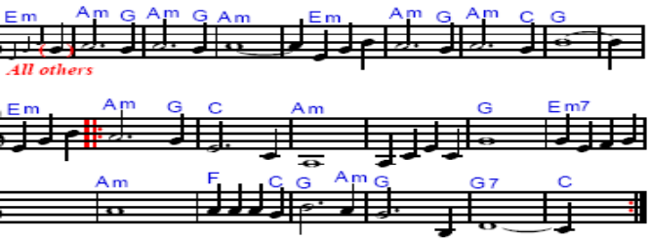

In C: →→→
In G:
→→→

In C:
In G:

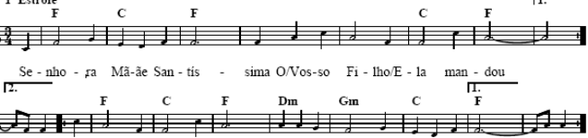

In Bb:
In G:
In C:
In Bm:
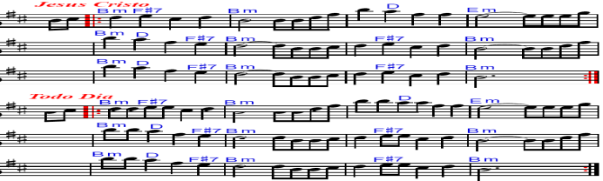 In Am:
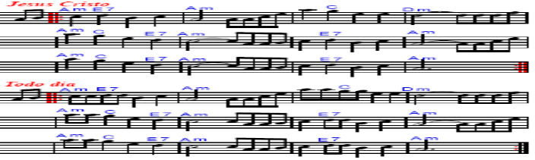
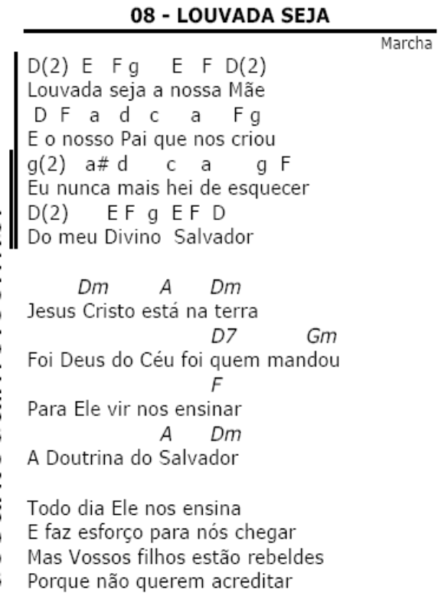
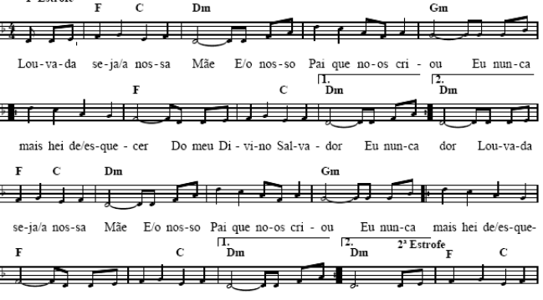

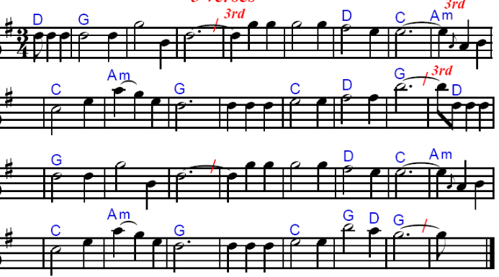
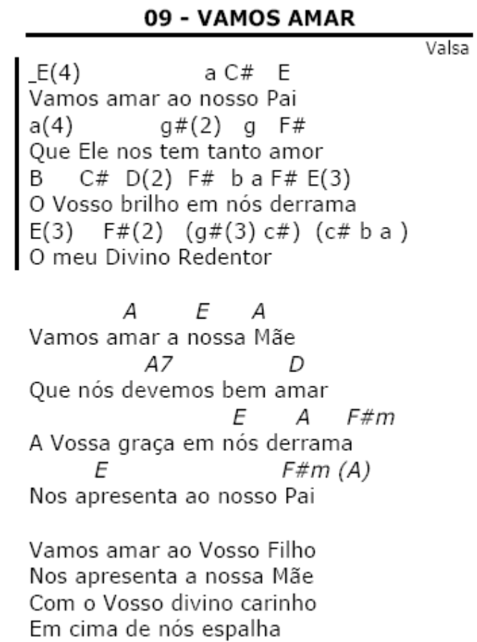

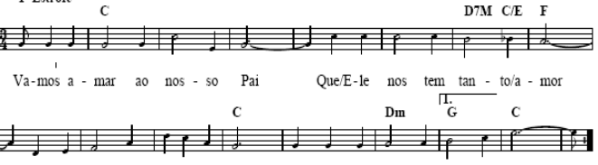
In C: →→→
In D:
→→→

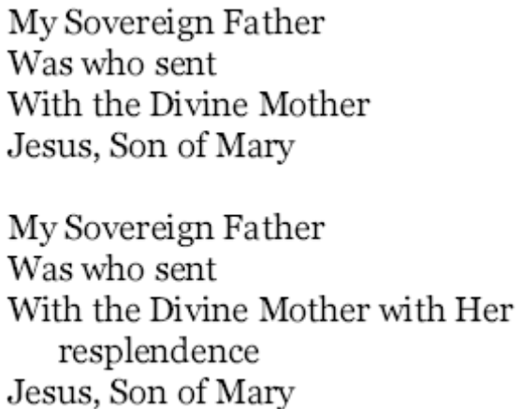

In C:
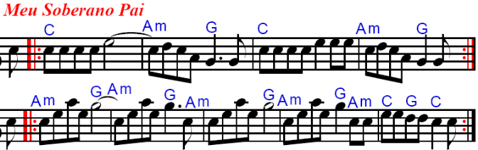

In D:
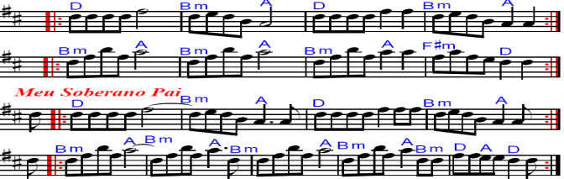
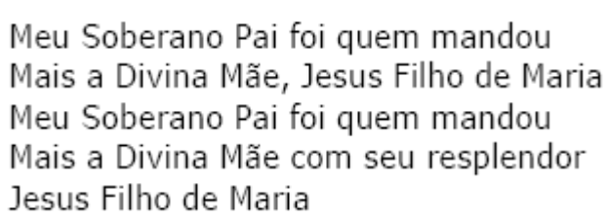

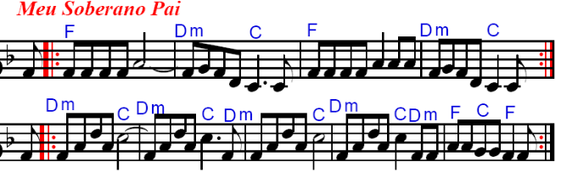

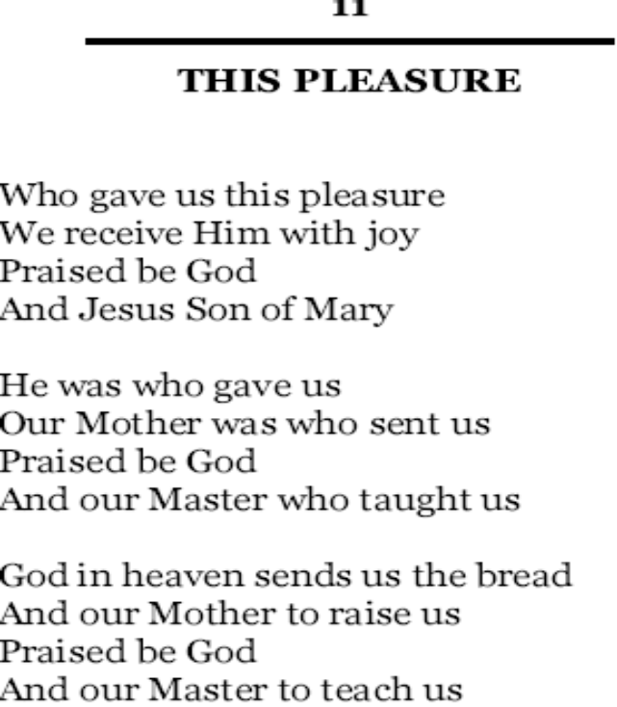
In C:
In D:

In C:
In D:

In C: →→→
In D:

→→→

In C:

In D:

In Am:
In Bm:
→→→

In D:
In F:
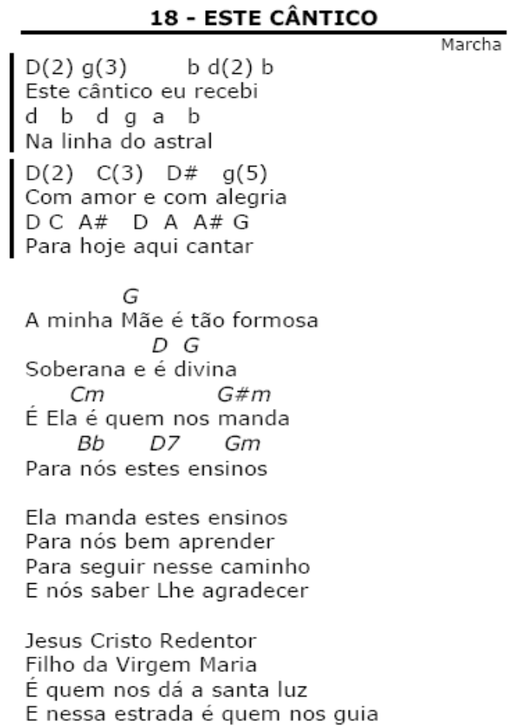
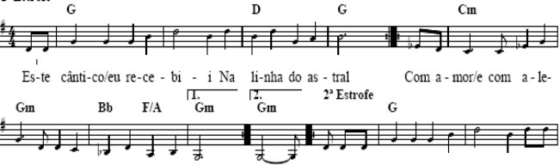
In C:
In G:

In Am: Note that “Trabelhemos” repeat starts on Root note →→→
In Em:
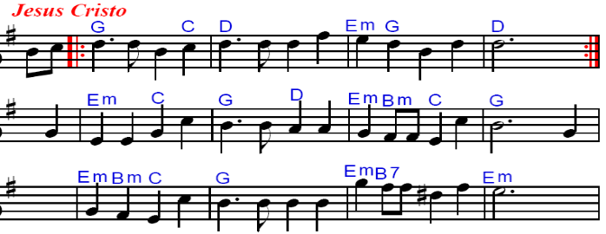
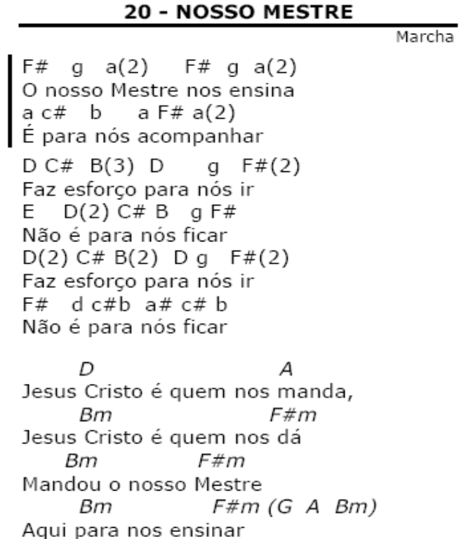
→→→
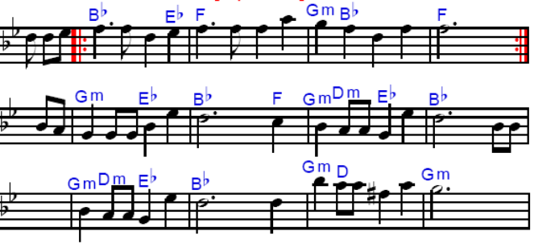
InAm:
In Em:

In C:
In G:
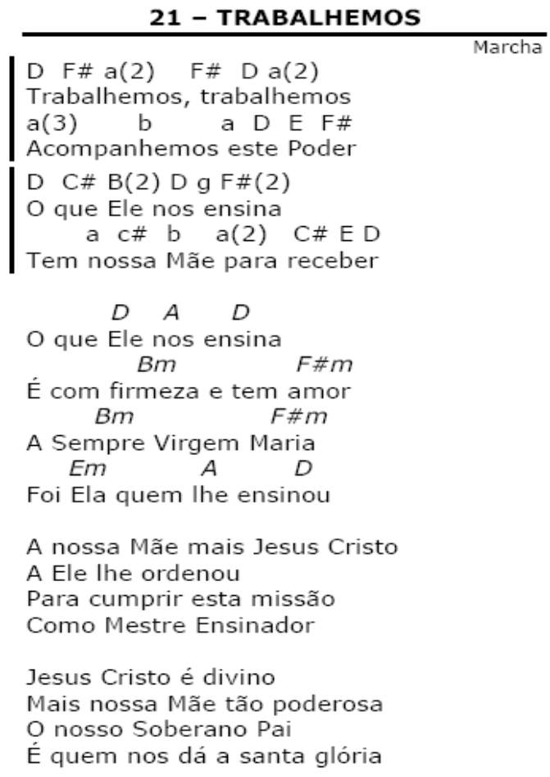
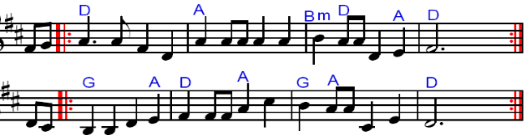
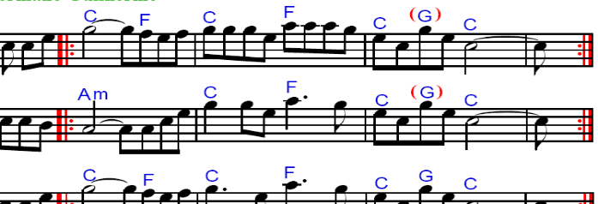
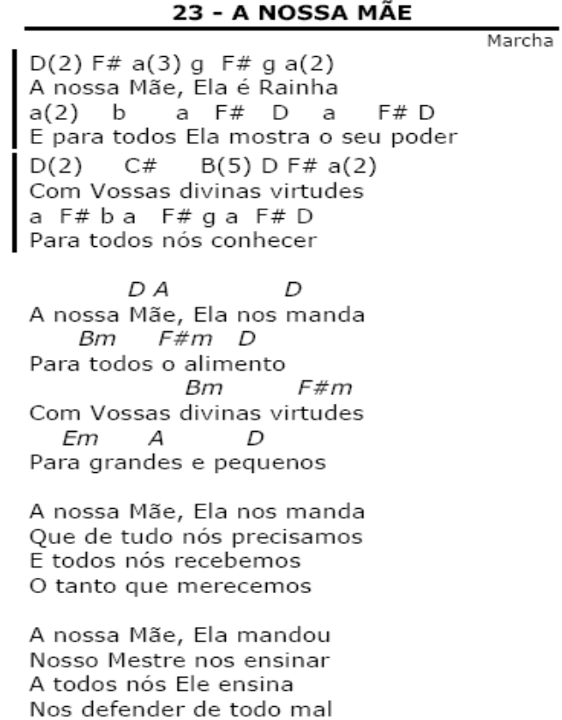
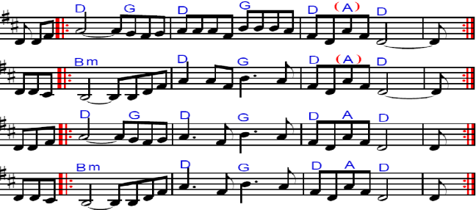
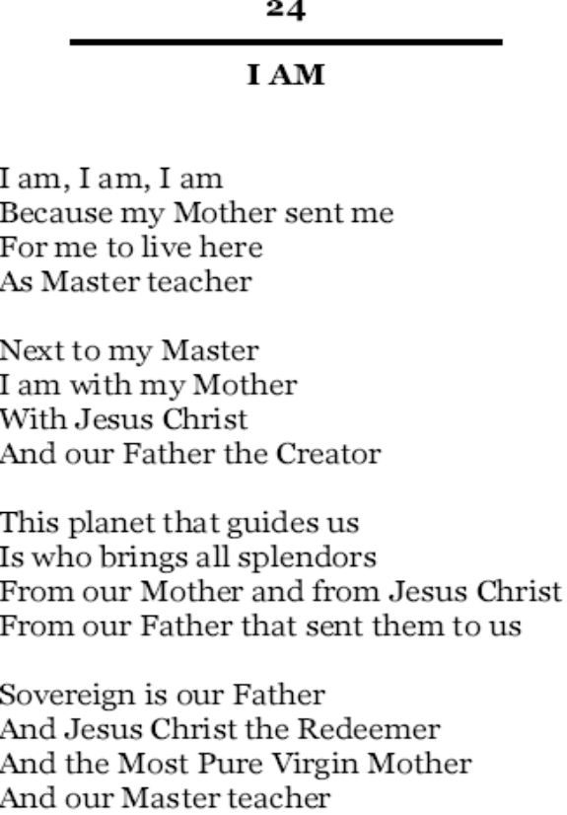
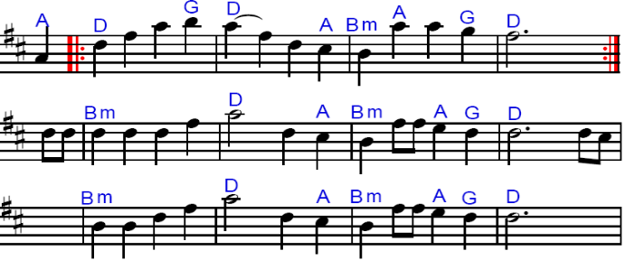
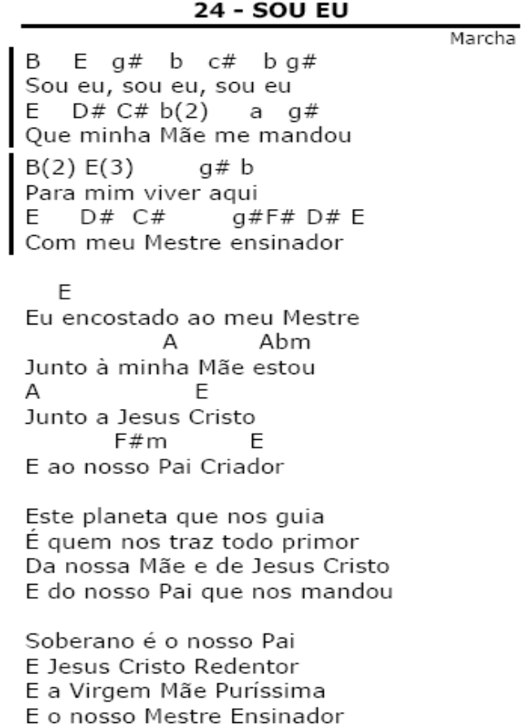
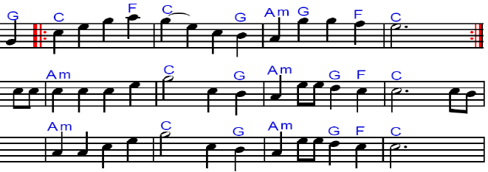
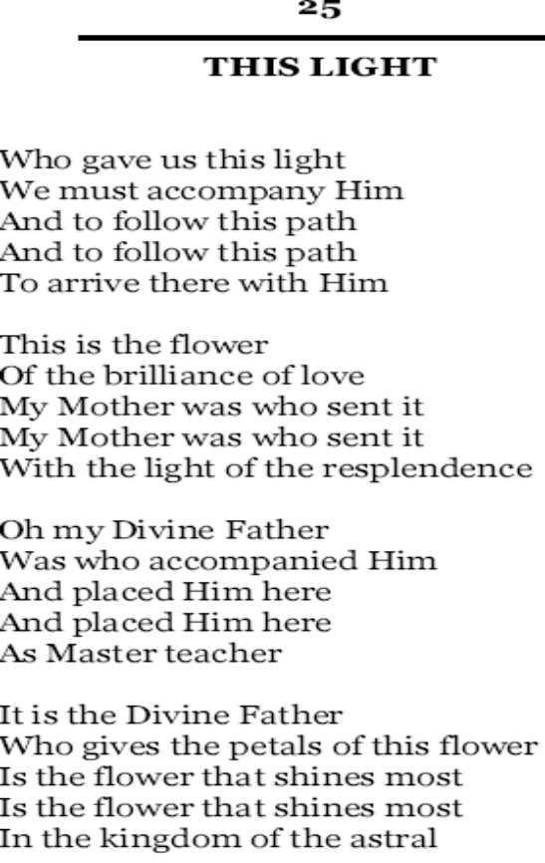
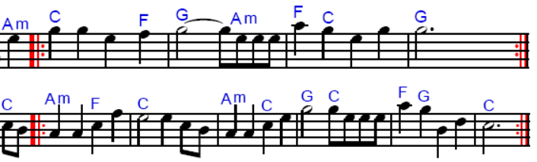

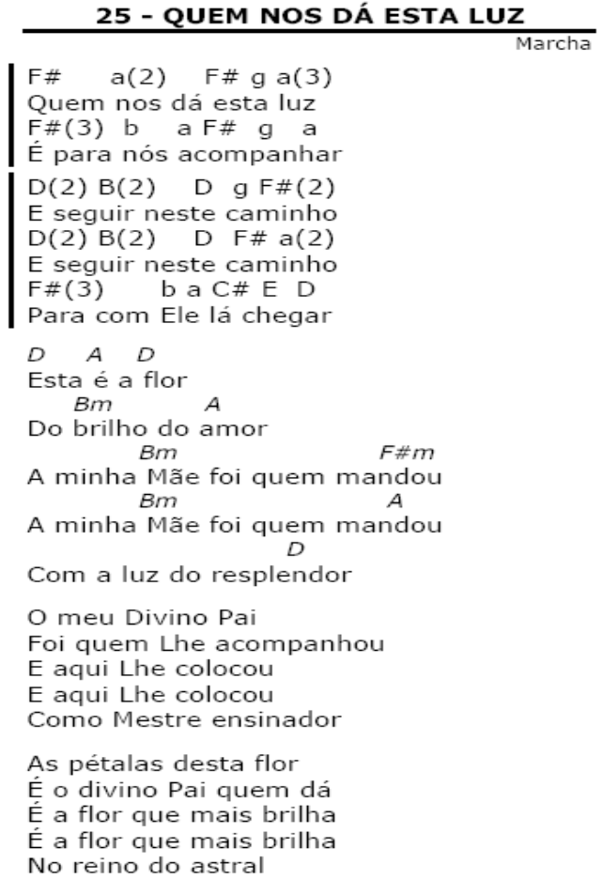
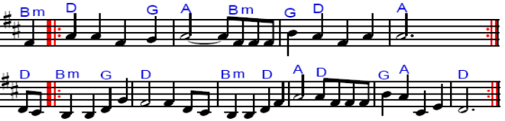
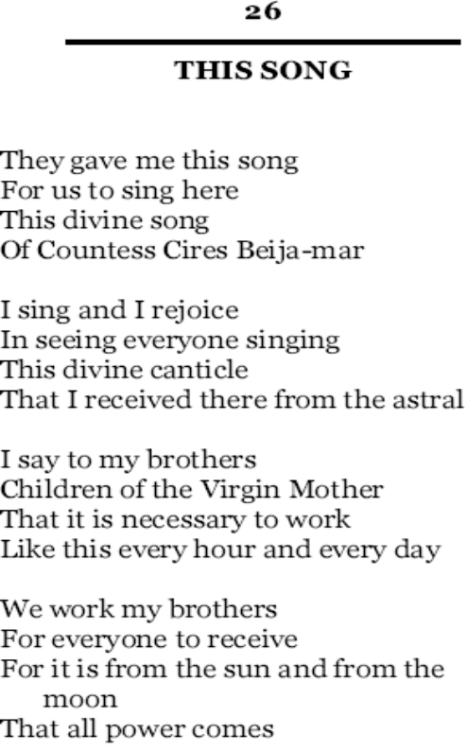
In C:

In D:
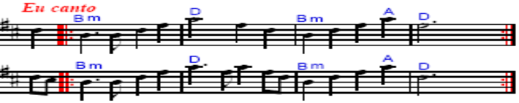
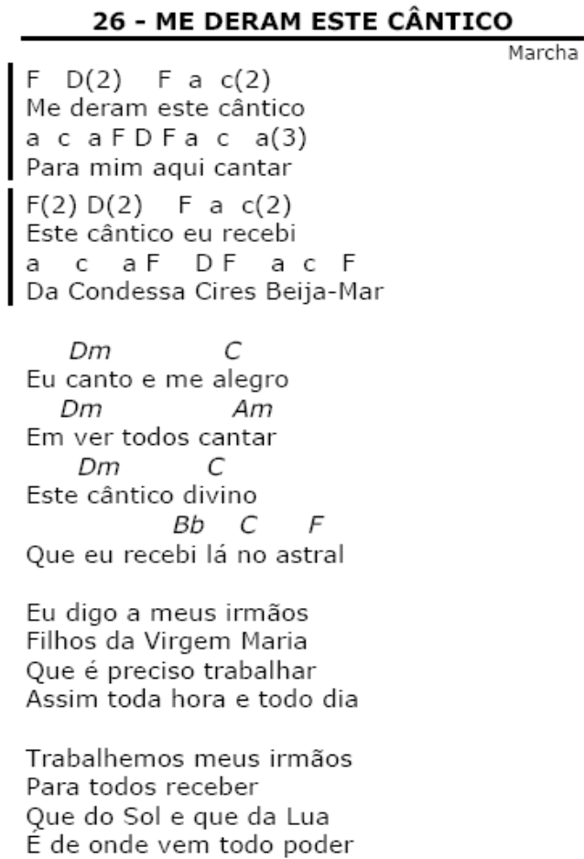

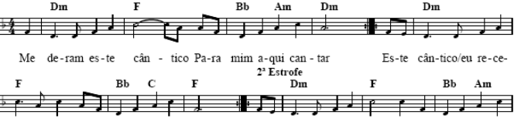

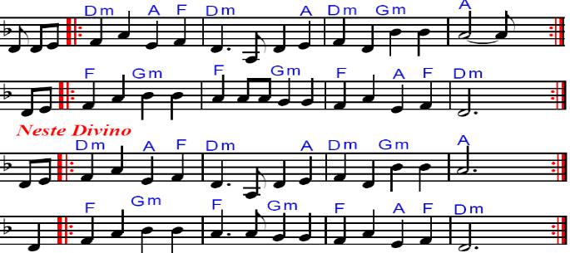

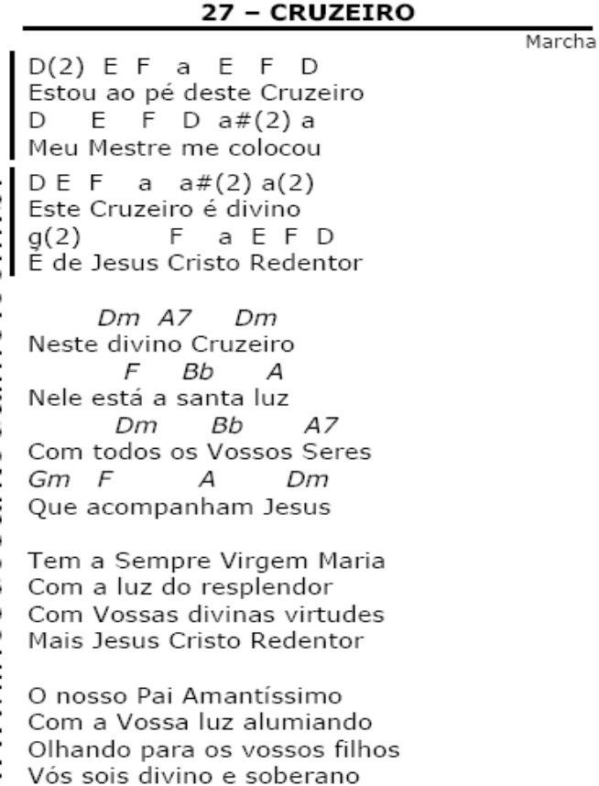
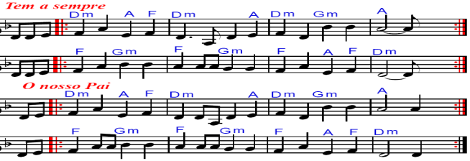
In C: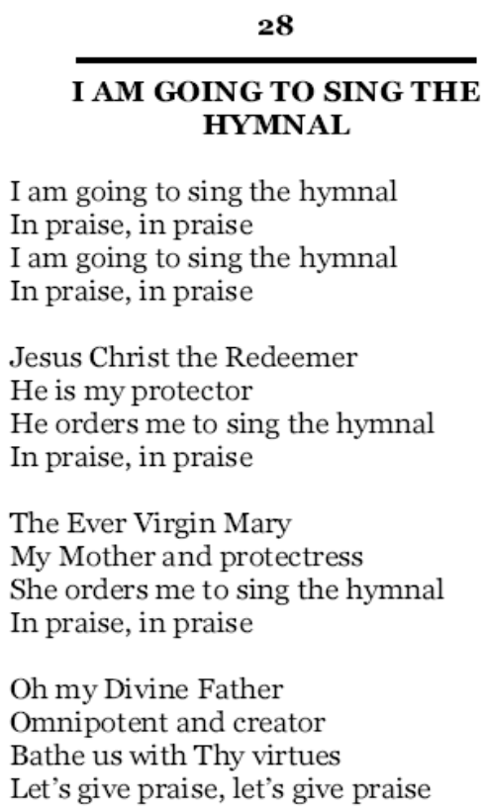
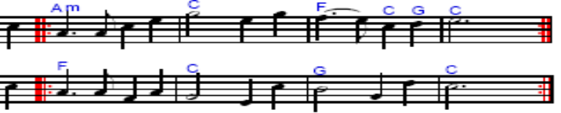
In F:
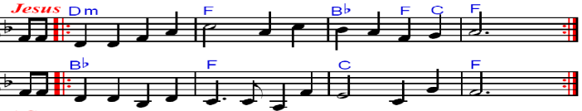
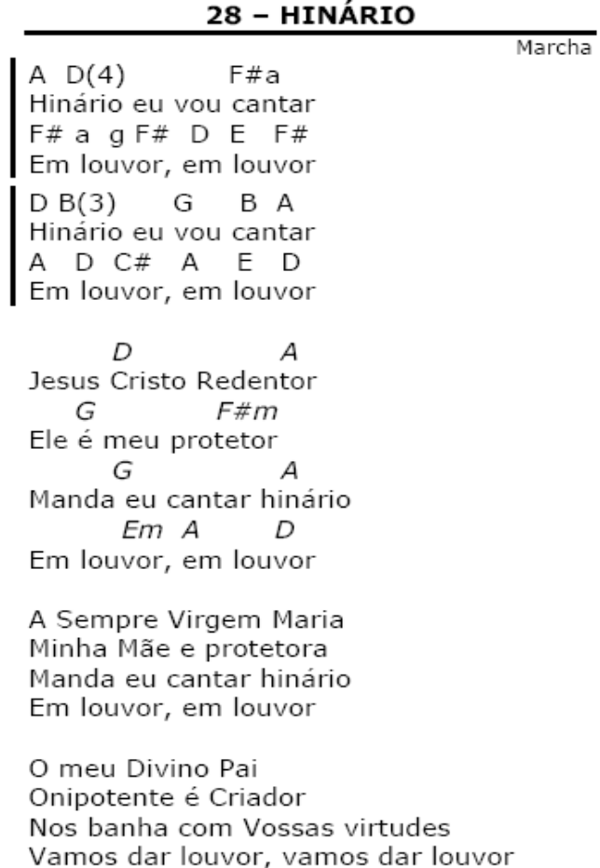
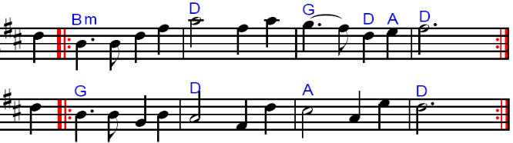
InC:
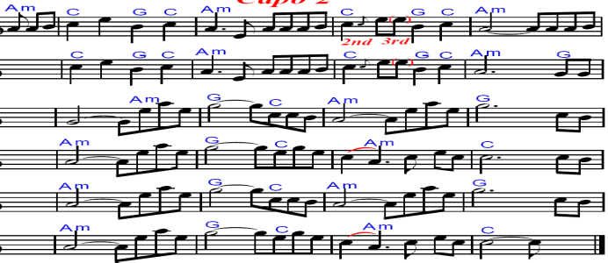
In D:

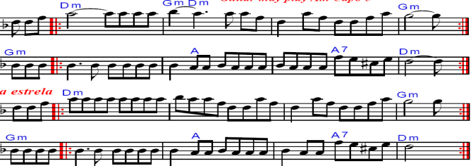
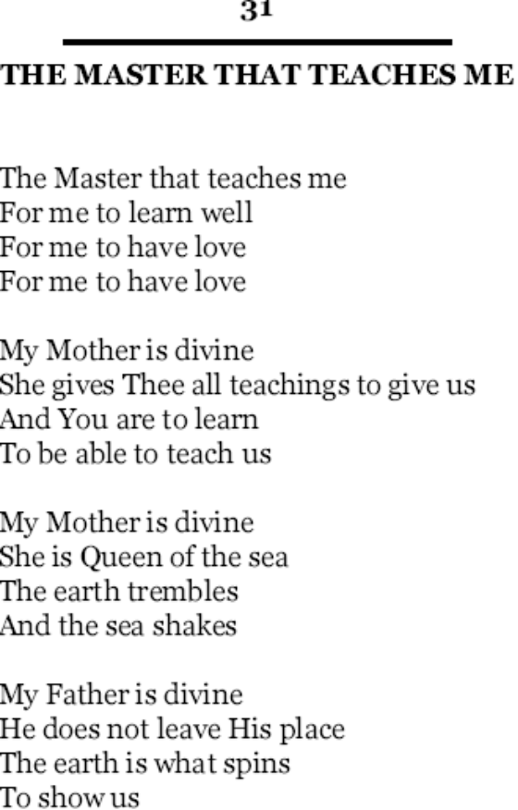
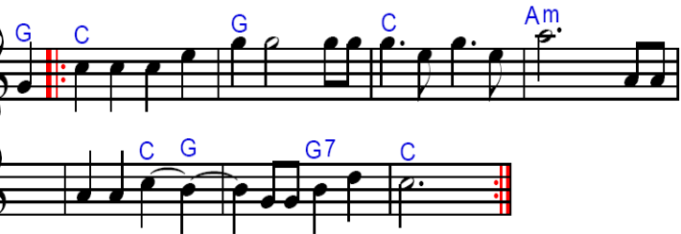
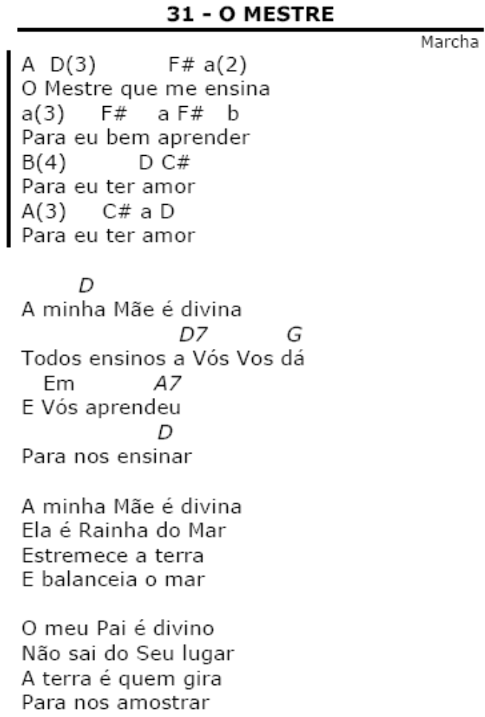
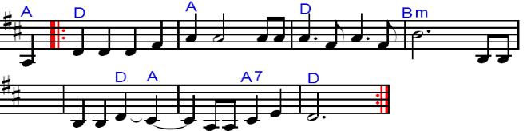

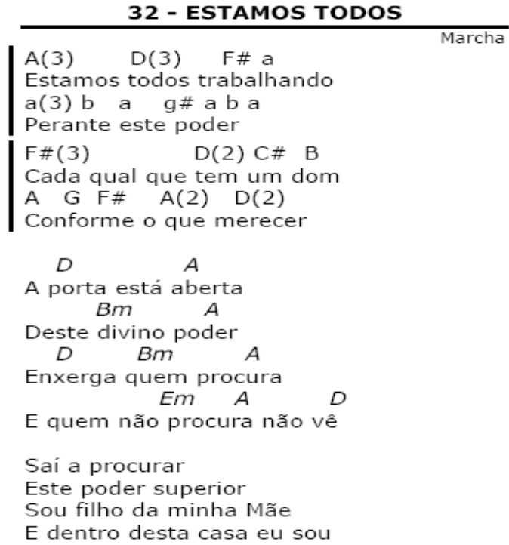
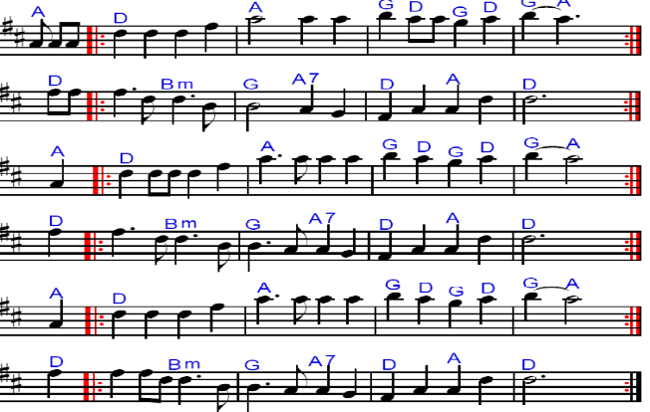
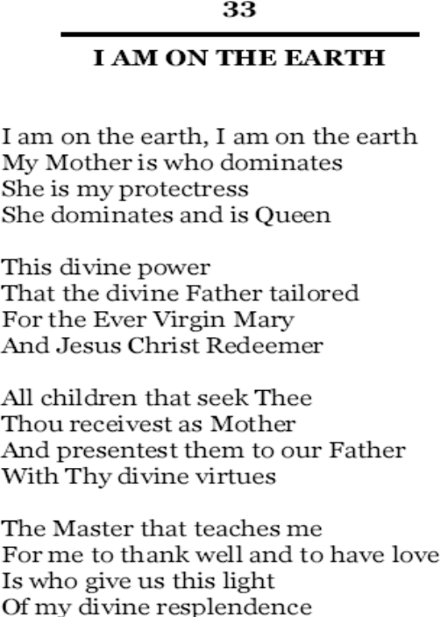
In C:In D:
In Am:
In Em:
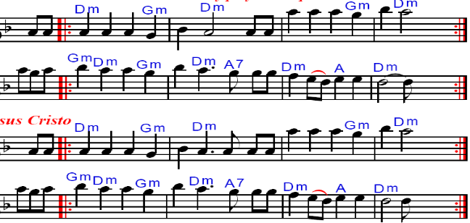
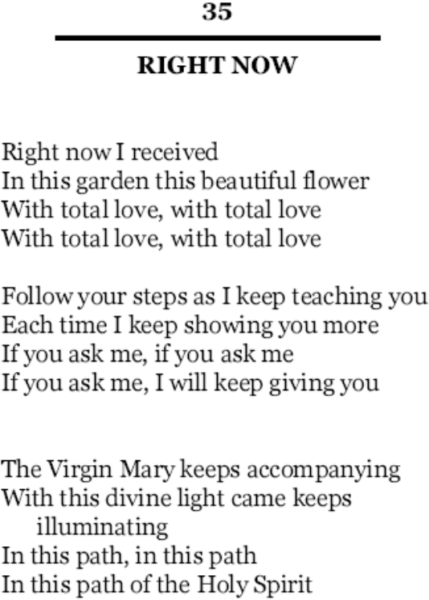

In Em:
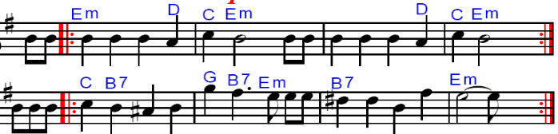
In F#m:
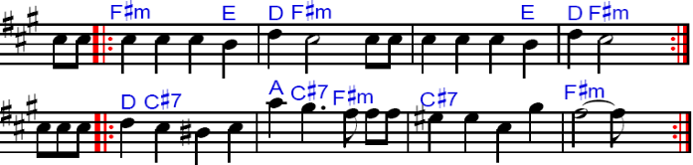

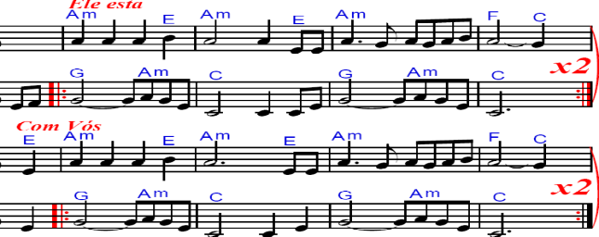
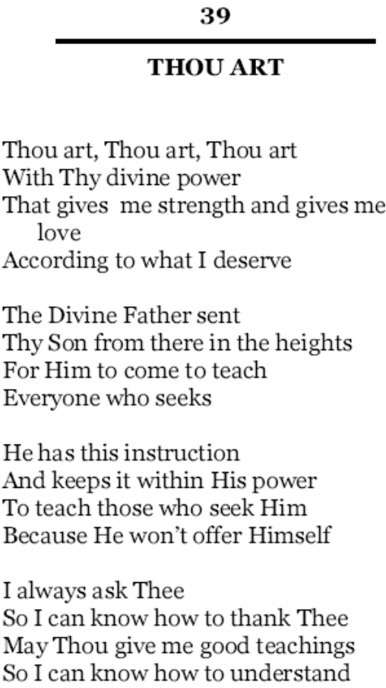
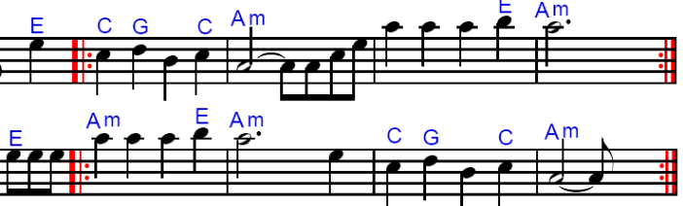
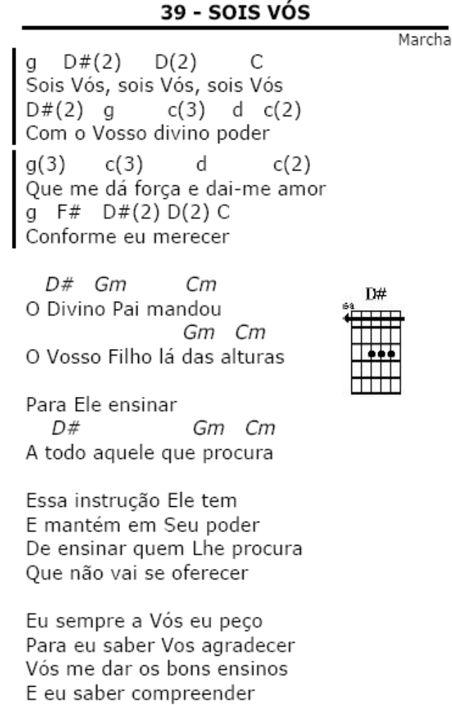

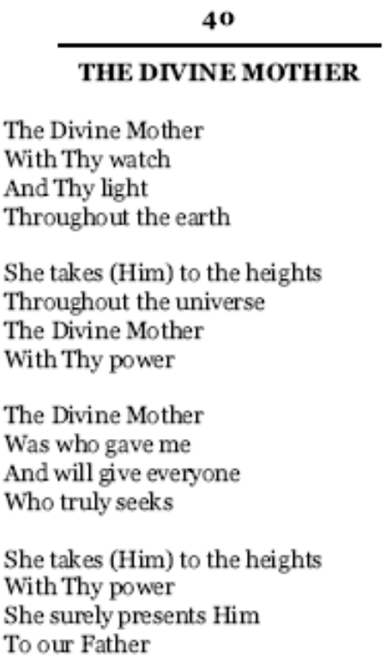→→→
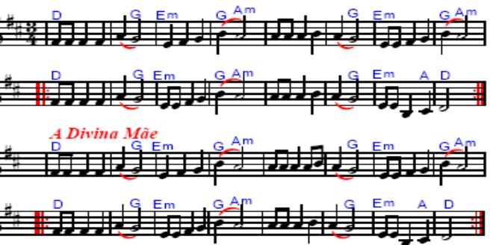
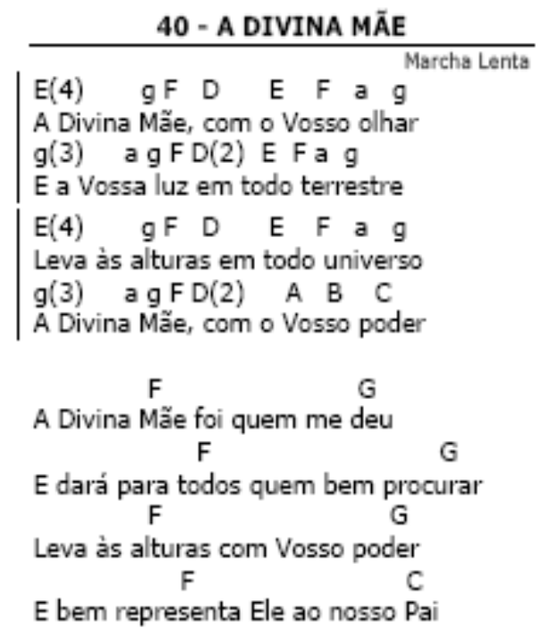→→→
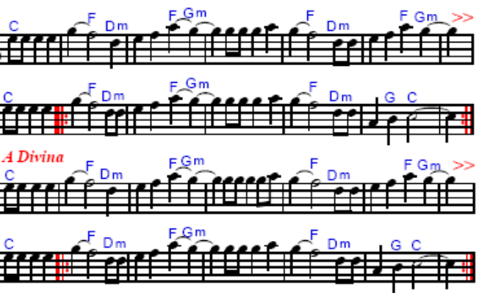
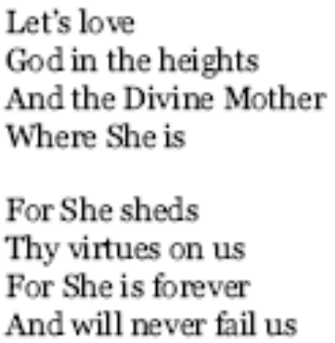
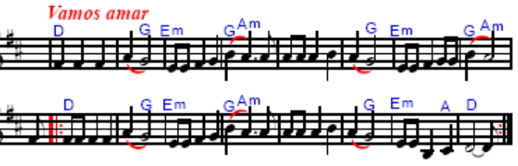

\

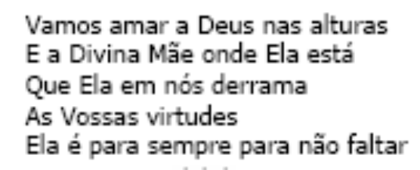

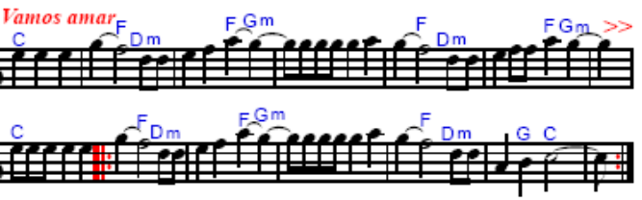

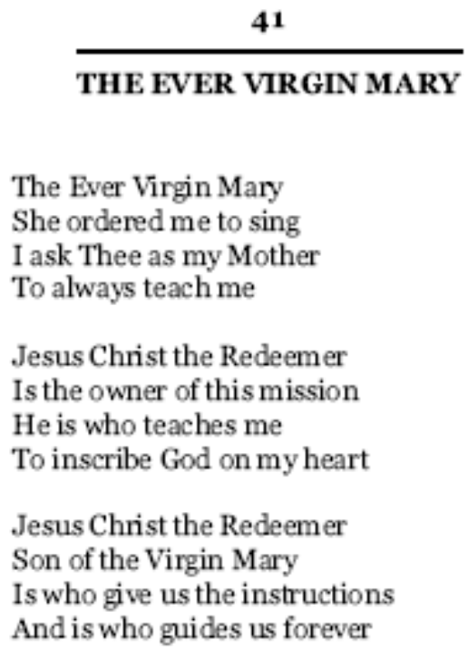
In Em:
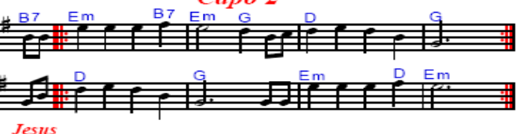
In F#m:
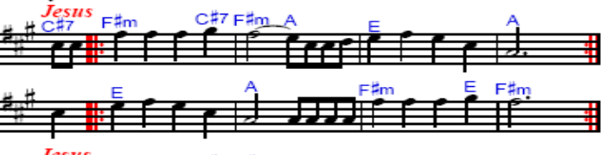
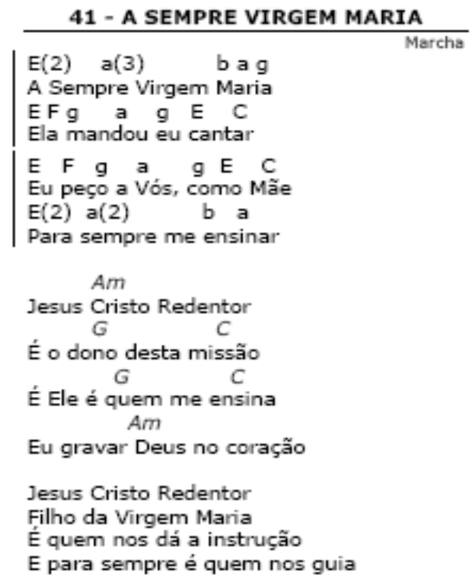
In Am:
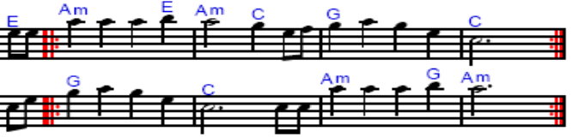
In Gm:
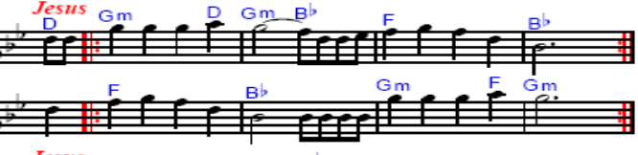
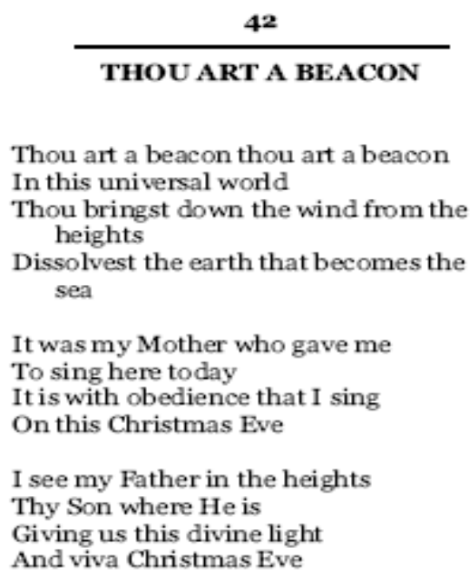
In Em:
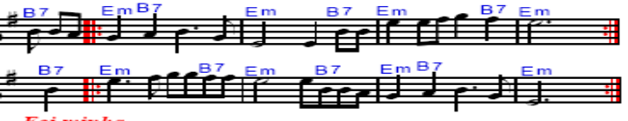
In Gm:
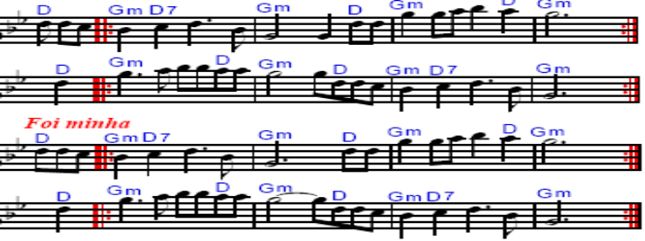
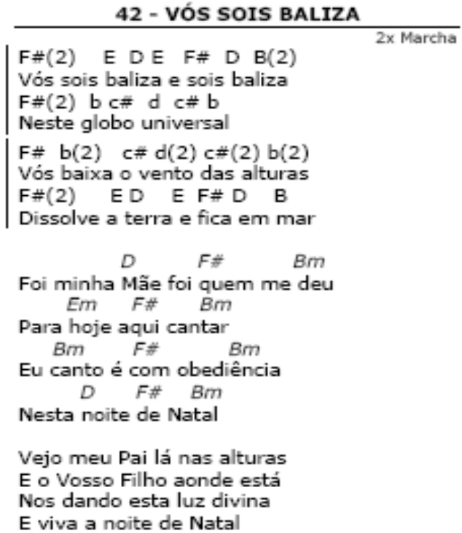
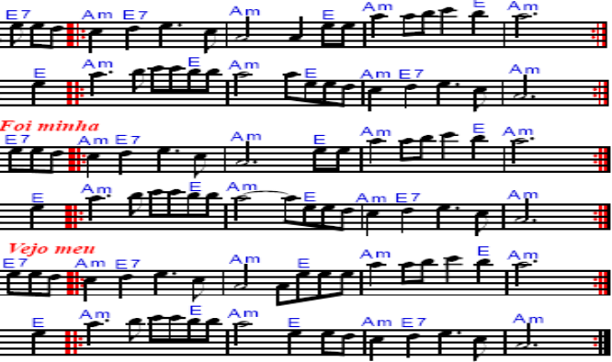
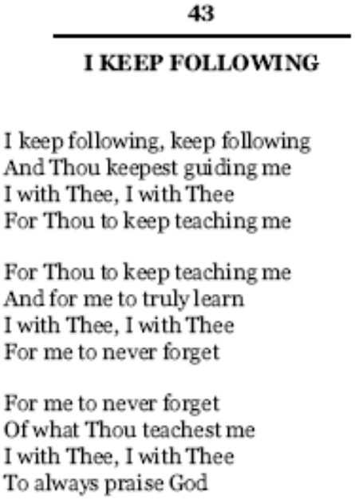
In Em:
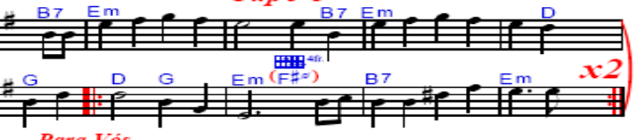
In Gm:
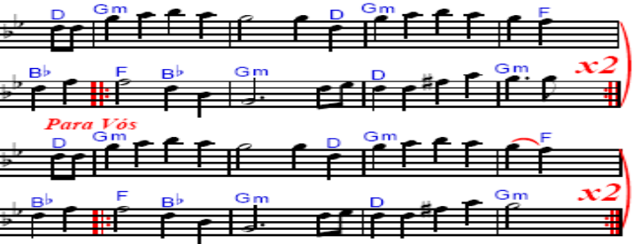
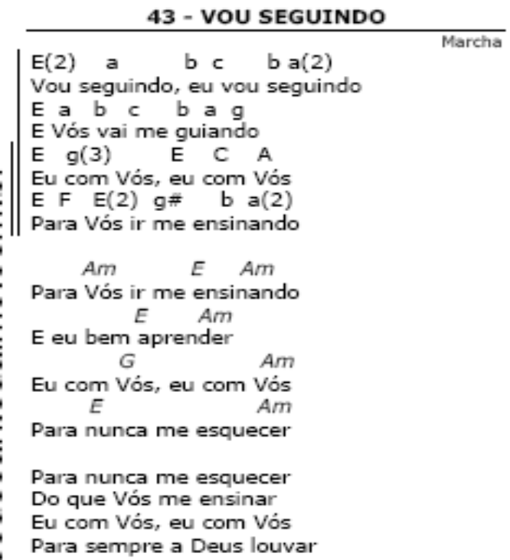
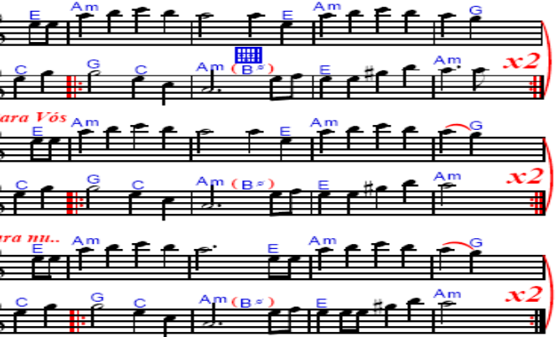
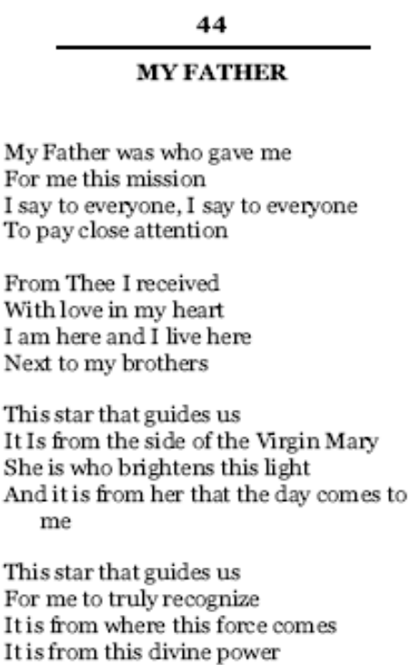
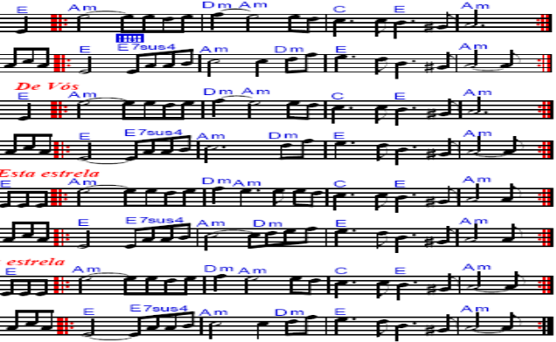
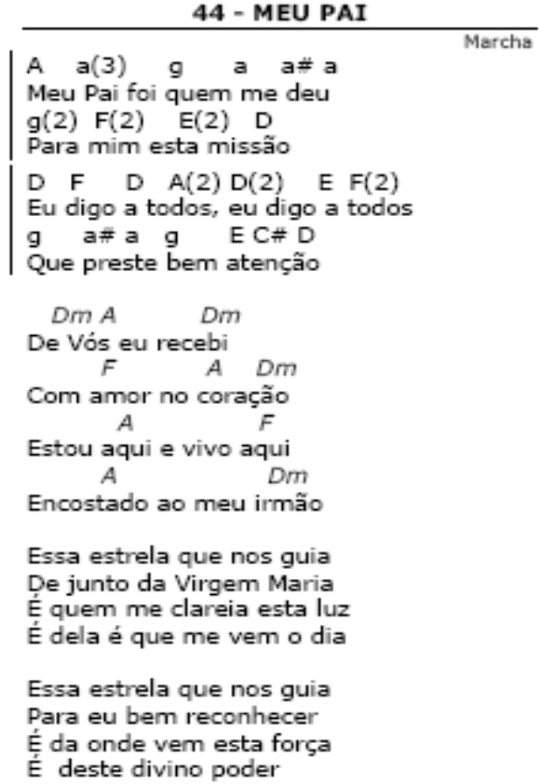
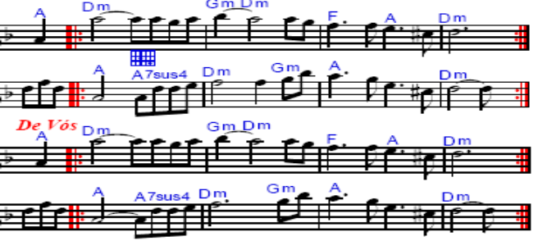
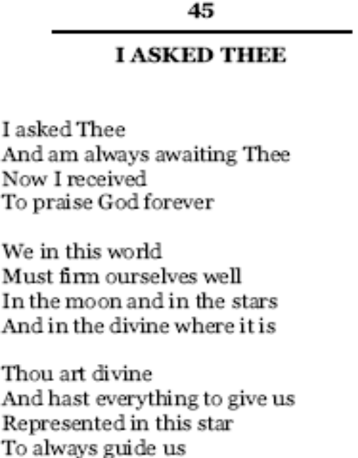
In Em:
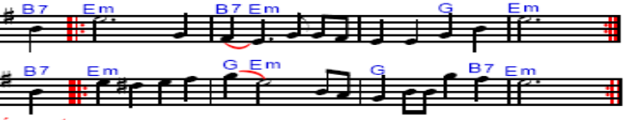
In Gm:
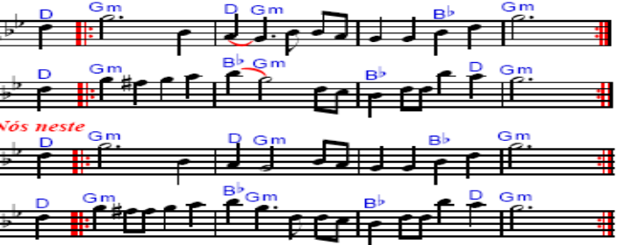
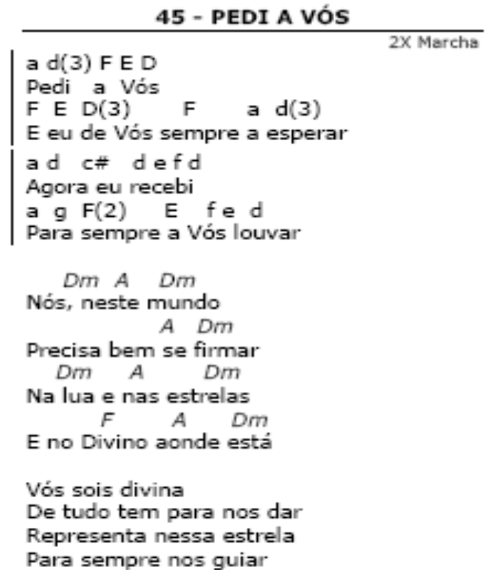
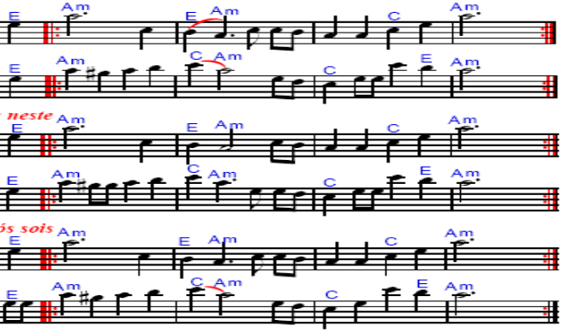
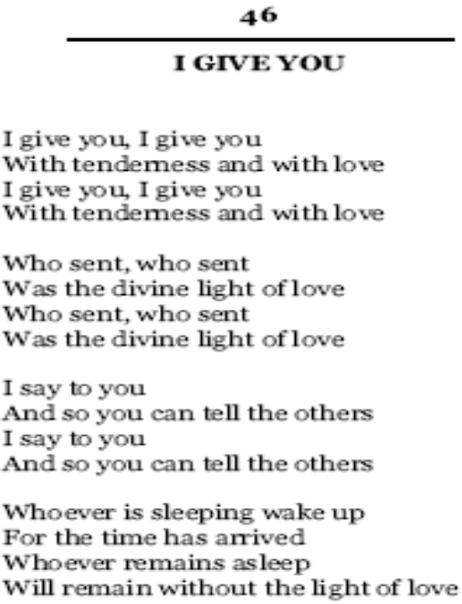
InCm:
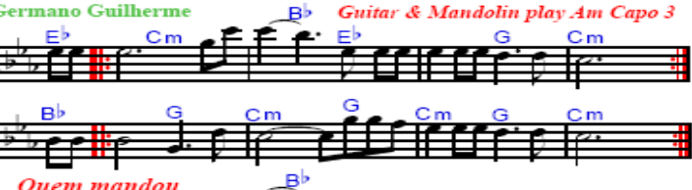
In Am:
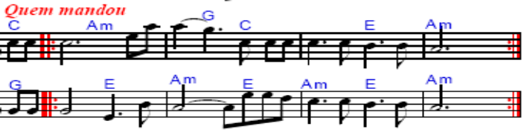
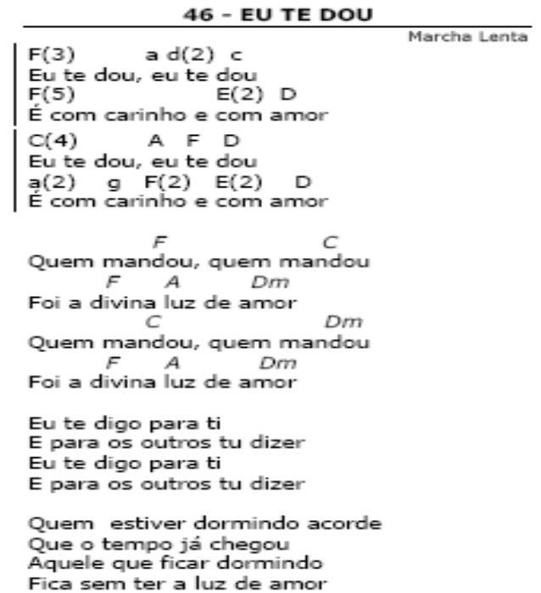

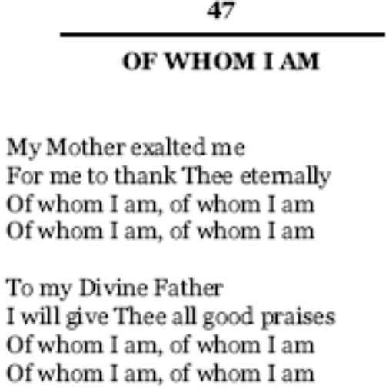
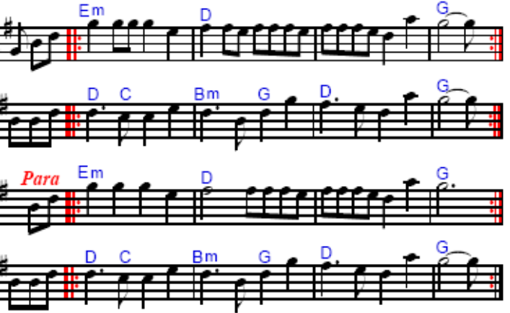

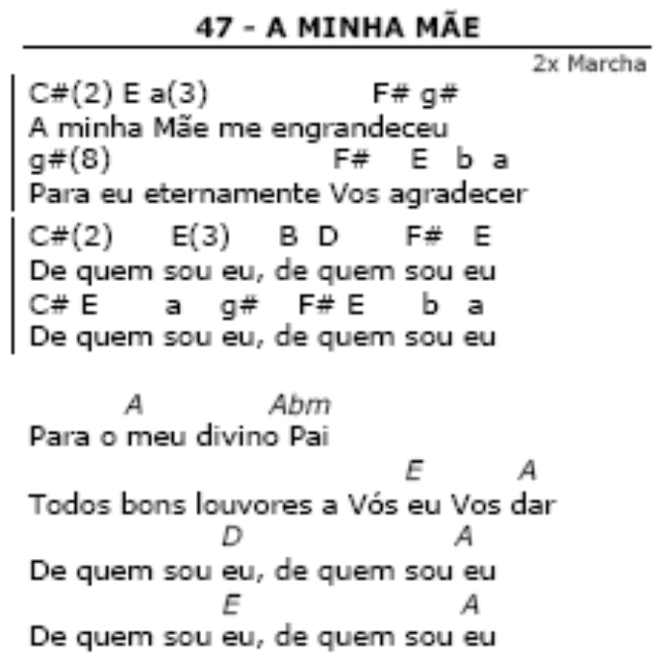
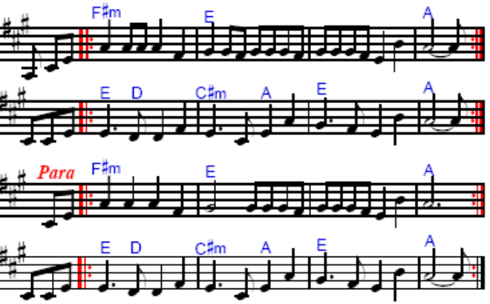


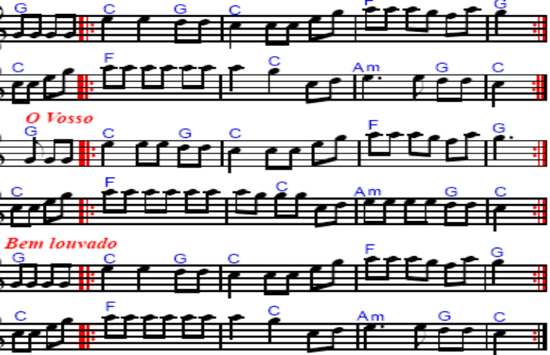

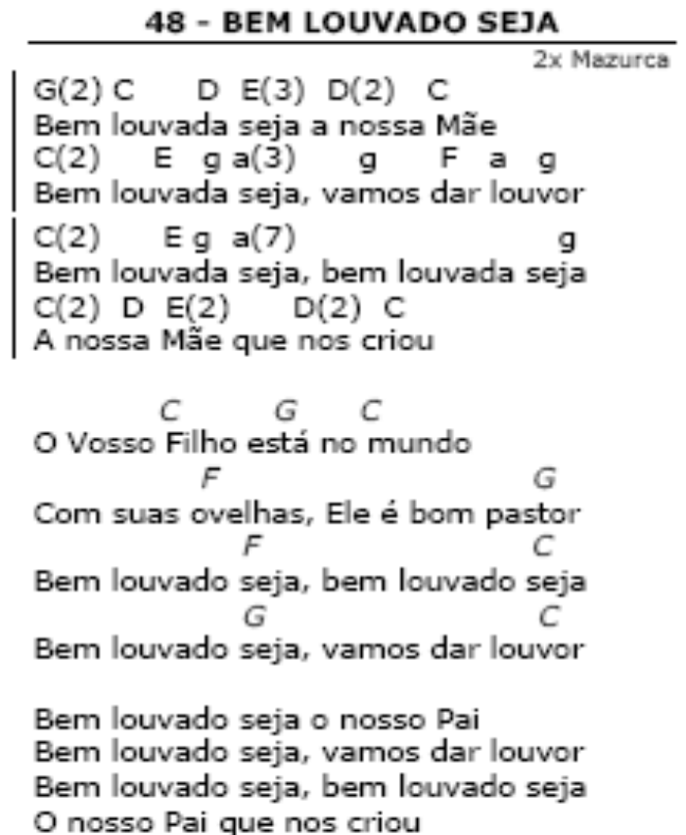

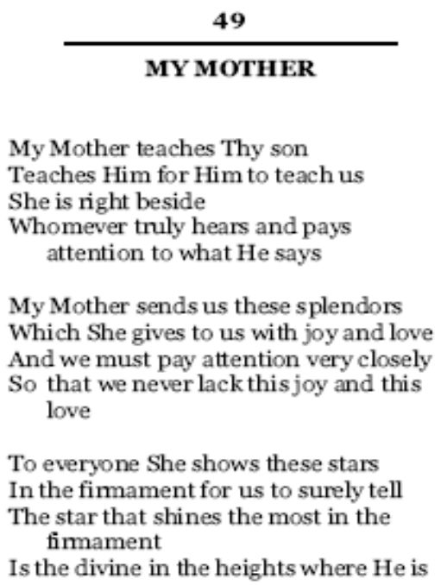
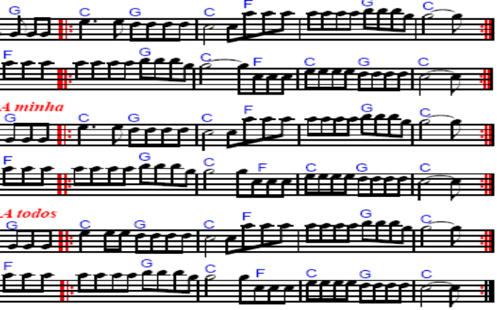
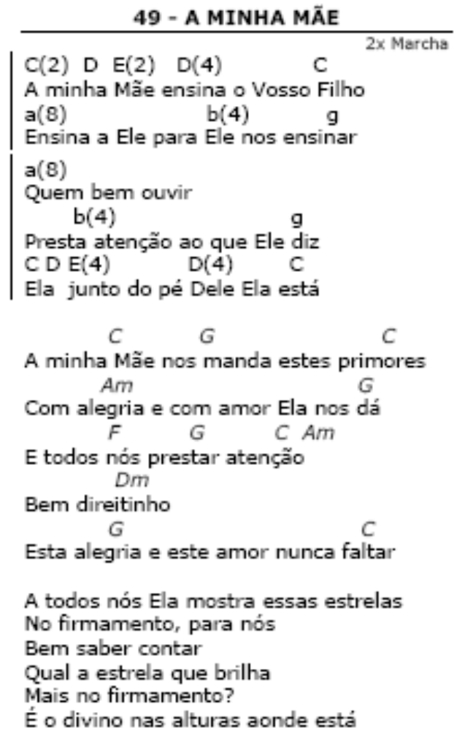

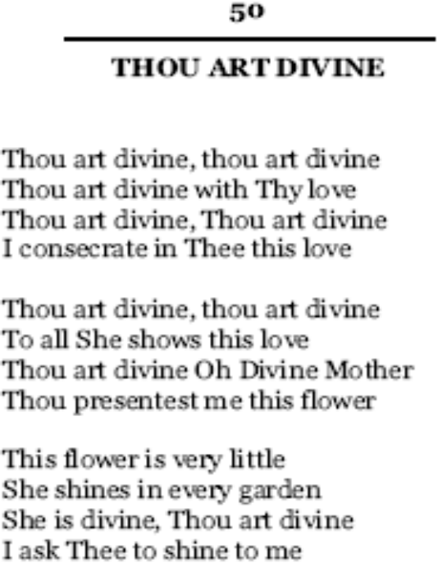
In Cm:
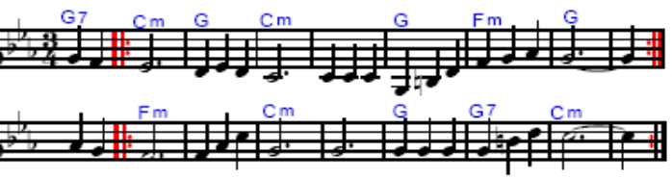
In Am:
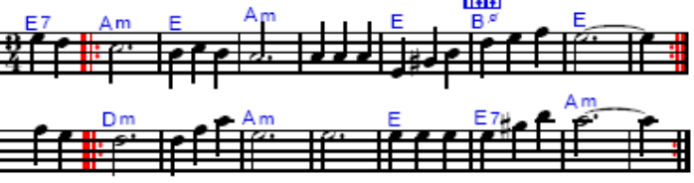
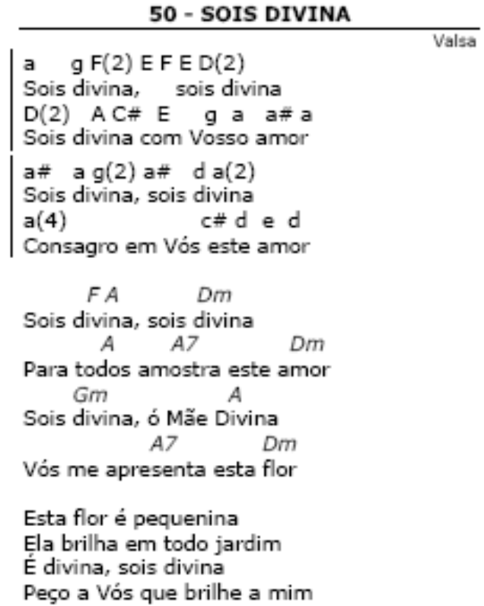

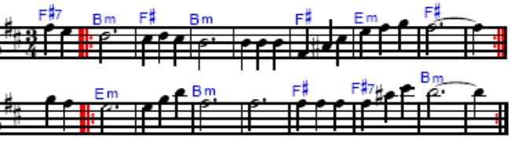

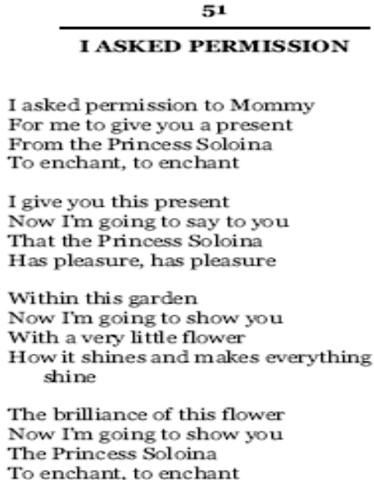
In Cm:
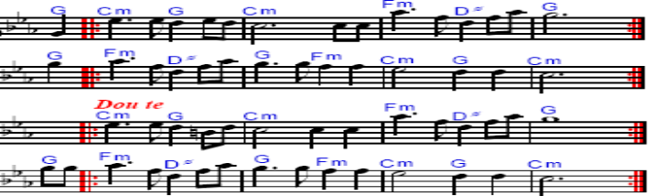
In Am:
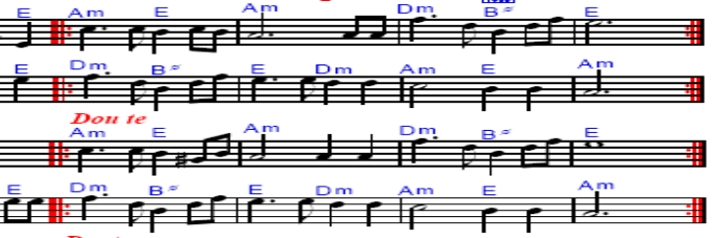
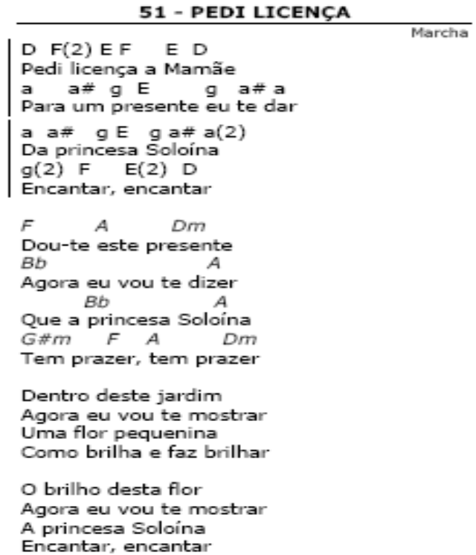
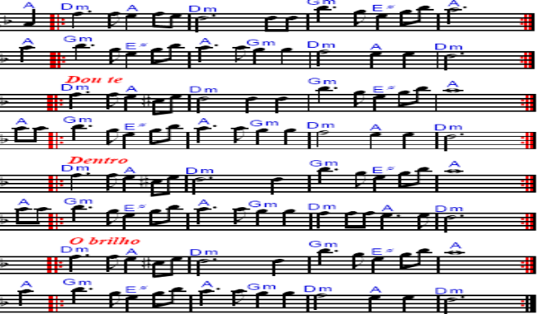

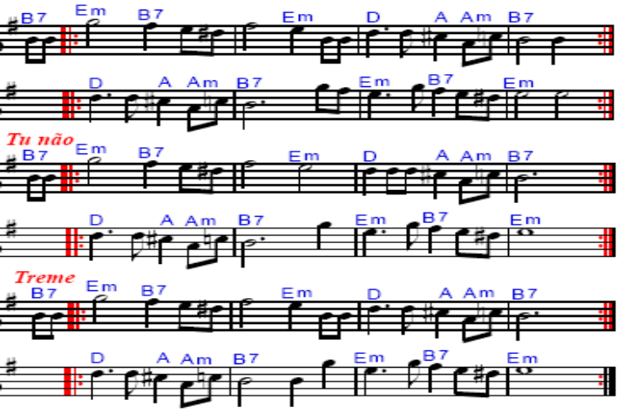
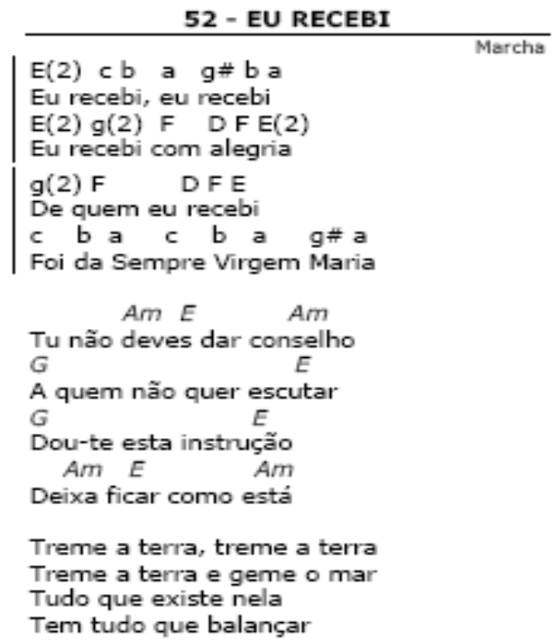

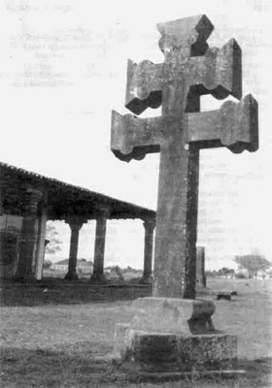

From A Familia Juramidam.com:
Antônio Gomes Da Silva was born in Ceará, on April 30th of 1885, where he married Ms. Maria Nazaré and had five children. After living in Belém do Pará he moved in 1921 to Rio Branco -- Acre, where he worked in the rubber plantation market and later on in the cultivation of the land.
Becoming a widower he married again, this time with Dona Maria, having of this marriage another four children. He met Mestre Raimundo Irineu Serra in 1938, receiving from him a great benefit for his shaky health. Antônio Gomes joined the doctrine together with his whole family.
As narrates Jairo Carioca's personal account:
Brazil was still under the dictatorship regime of Getúlio Vargas. In the state of Acre ships still would bring entire families of north easterners that were running away from the drought, seeking a better quality of life in the region. “In one of those ships, narrates Ms. Zulmira Gomes, daddy brought us here. We suffered a lot during the ship journey until here but we arrived with faith in God. Here, after a wile, daddy was very sick, feeling a very strong mind perturbation and I was tired to look all around on the search for his cure. *Compadre Zé das Neves asked if I didn’t know the session of a tall black guy that was doing healings in Vila Ivonete. I said no. He insisted until he convinced me to go there. I presented myself to Mestre, he looked at the state of my father and made an appointment for the next Wednesday as the beginning of his healing work. But he walked out of there better at the same day (she smiles), and with three healing sessions he was cured. Then my father said he would never abandon that (spiritual) work,” narrates Ms. Zulmira Gomes.
In this way the Gomes family presented themselves to the session of Raimundo Irineu Serra. This story Ms. Zulmira liked a lot to narrate. Sometimes, whenever I would go visit her in *Alto Santo, I would get impressed with her memory capability. On a very advanced age and well tired of the suffering routine lived until then, Ms Zulmira would never get tired to speak of the past. With a dry branch in hand (to cast away flies), always that a newcomer would arrive in Alto Santo, there she was narrating the unforgettable moments lived by Mestre’s side.
She narrates the end of the first formation cycle of the doctrine. Mestre Irineu, which was already giving the first steps in the institutionalization of his works, relied on a considerable group of followers. Of the new family, besides Antônio Gomes da Silva, the patriarch, his children Leôncio Gomes, Raimundo Gomes, Adália Gomes, José Gomes and Ms. Zulmira Gomes also started to attend the sessions. Ms. Zulmira, married to Mr. Sebastião Goncalves, took his children Raimundo Gonçalves, João Gomes, Benedita Gomes, Eloisa Gomes, and Peregrina Gomes to the mission. This family strengthened the edification of the doctrine like Antônio Gomes himself who started to receive a rich and instructive hinário where he narrates: “Mestre worked, was seeing himself almost alone, and asked of Jesus Christ to open his path."
His son, Leôncio Gomes, was the one who replaced Mestre Irineu in the direction of the works, after his passage, in 1971. Antônio Gomes Da Silva died in August 14th of 1946.
***
Mr. Antônio Gomes was the brother who first received a mazurka in the doctrine. He (Antônio Gomes) was who taught the brothers and sisters to dance the mazurkas that were being received by others. Antônio Gomes also was who, in the eve of the works, went to the houses of the brothers and sisters who had an edge with one another, asking for peace in between them. He had the incumbency of appeasing the brothers and sisters who were with conjugal problems, in other words, he was known at that time as the messenger of peace; Divine Love.
Mrs. Adália Gomes, wife of Mr. Francisco Grangeiro, since the age of eight years old received from her father, Antônio Gomes, the task of caretaking his hinário, today known as “Divine Love”. Mrs. Adália reminds of the works since when they were brought by Mestre Irineu from Brasiléia to Vila Ivonete.
Guido Carioca

→→→

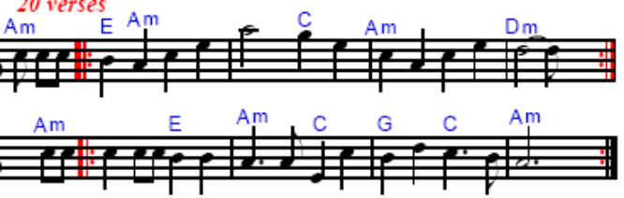
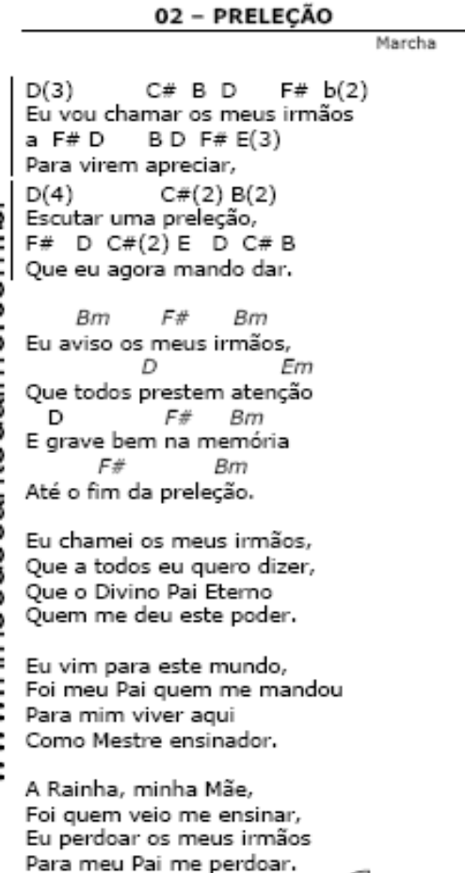→→→
→→

→→→

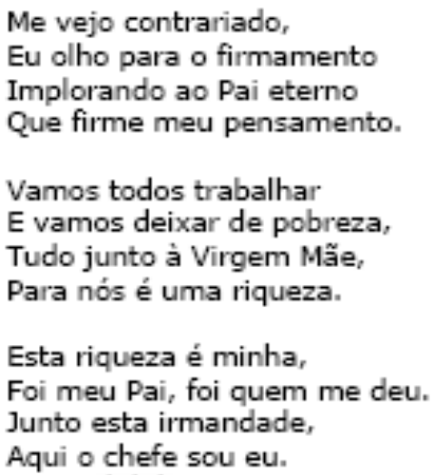

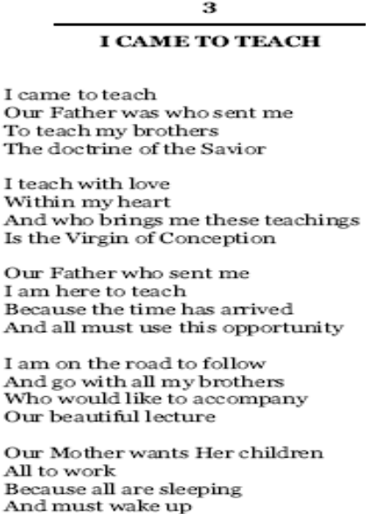→→→
→→

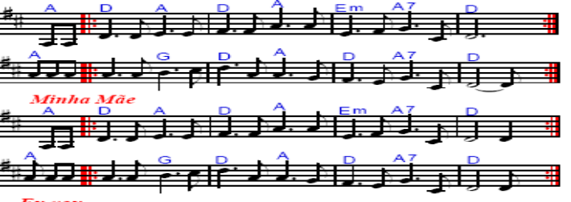
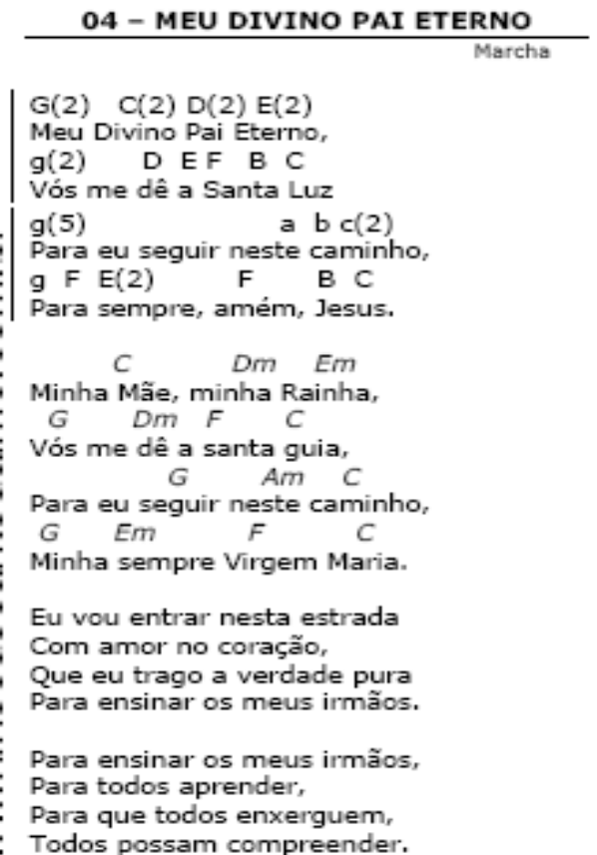
→→→
In Am:
In Bm: (Cm is over→)

→→→
In Am:
In Bm:
In Cm:
→→→
In Am:

In Bm:

In Cm:

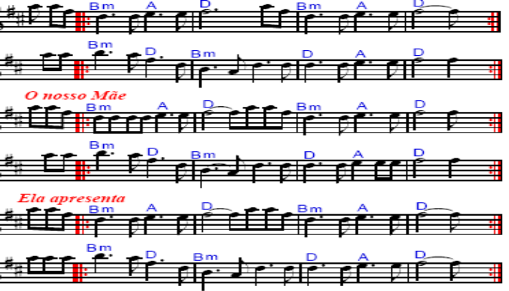
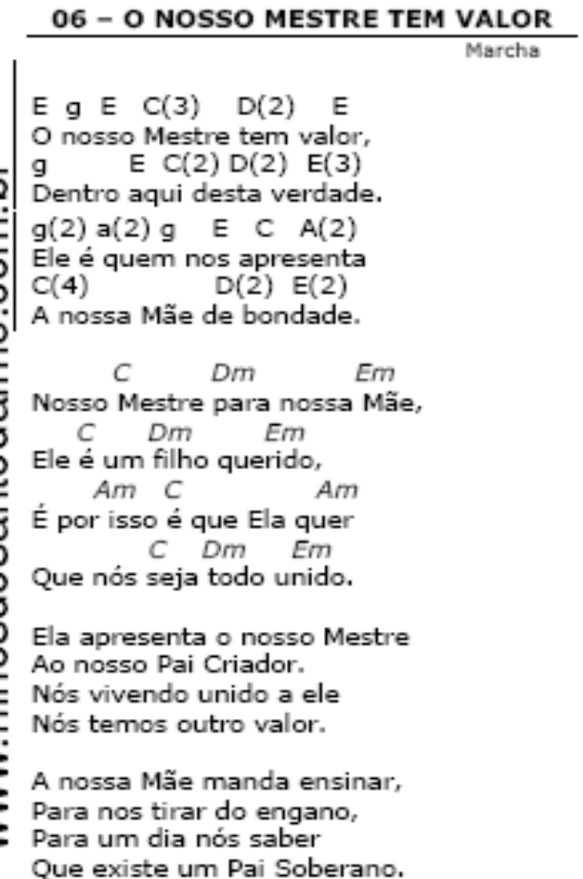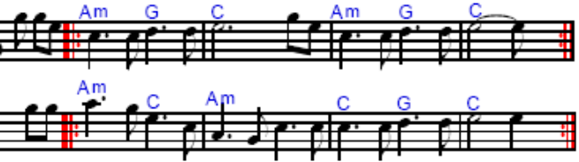

In Am:
In Bm:
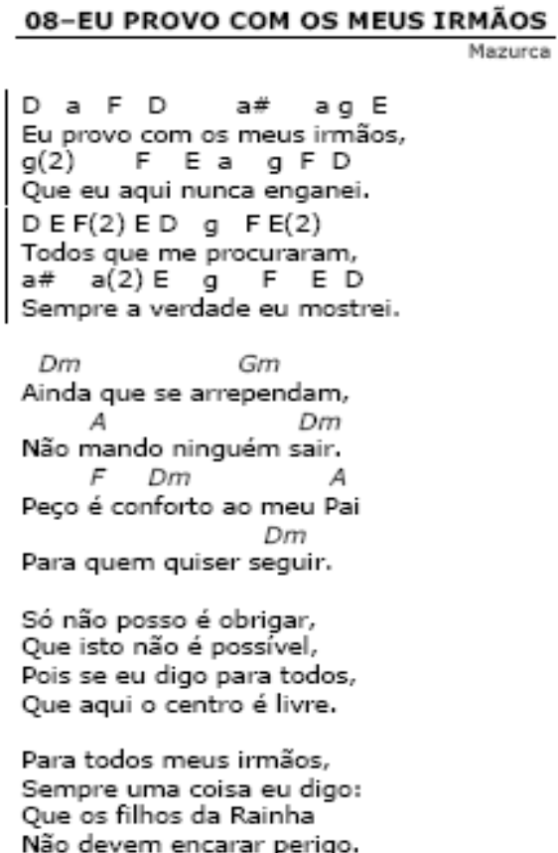

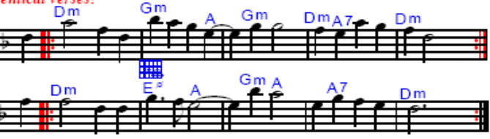

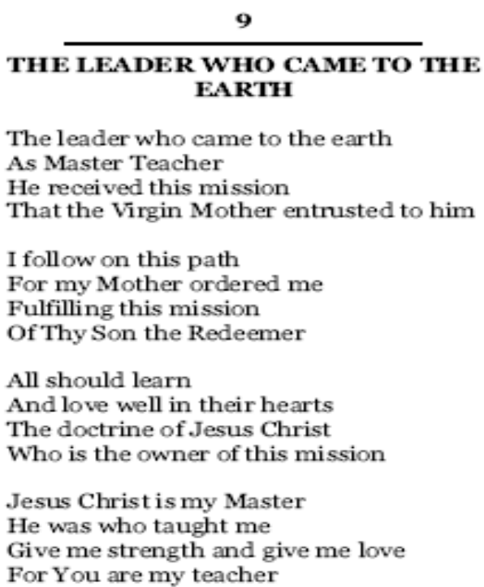
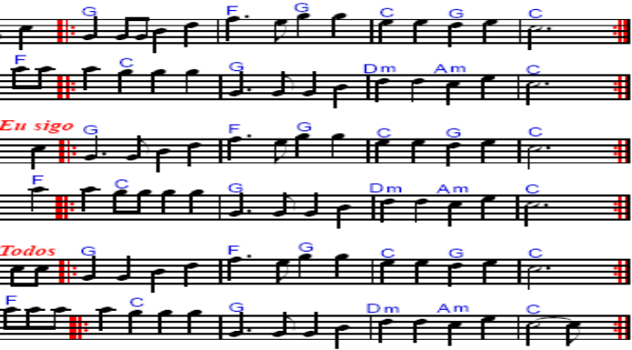

In A:
In C:
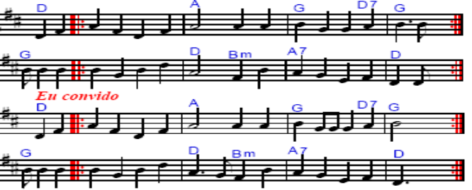
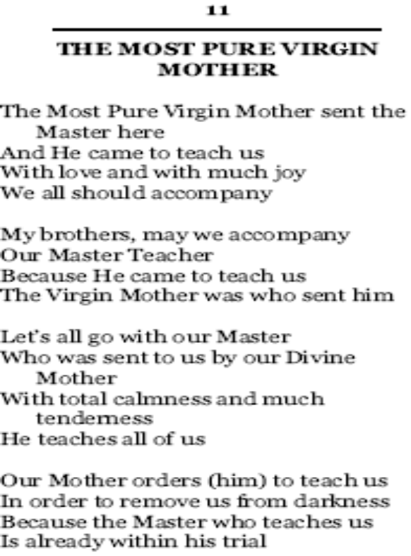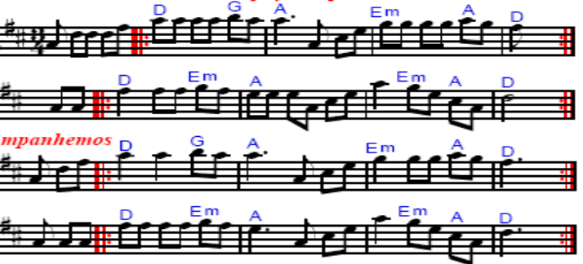
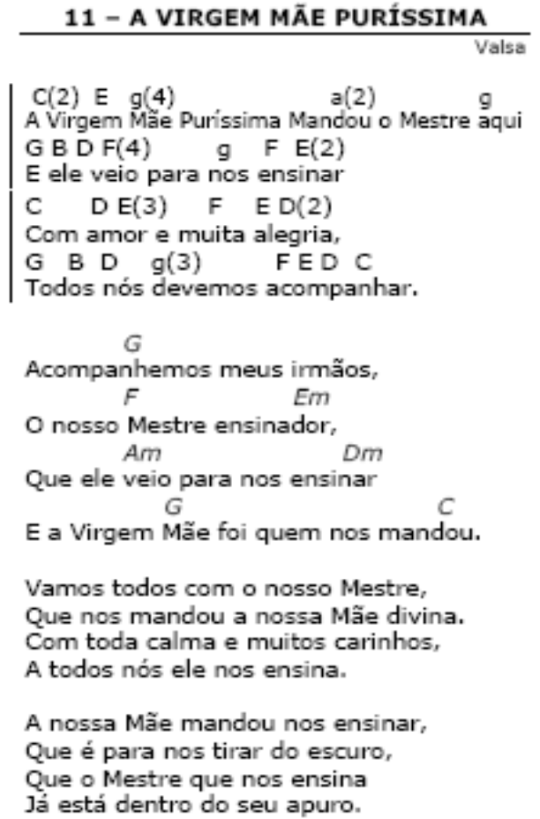

In Am:
In Cm:

→→→

→→→

In A:
In C:
→→→

In A:
In C:

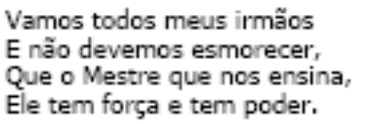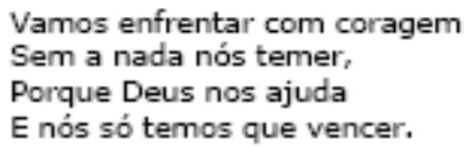

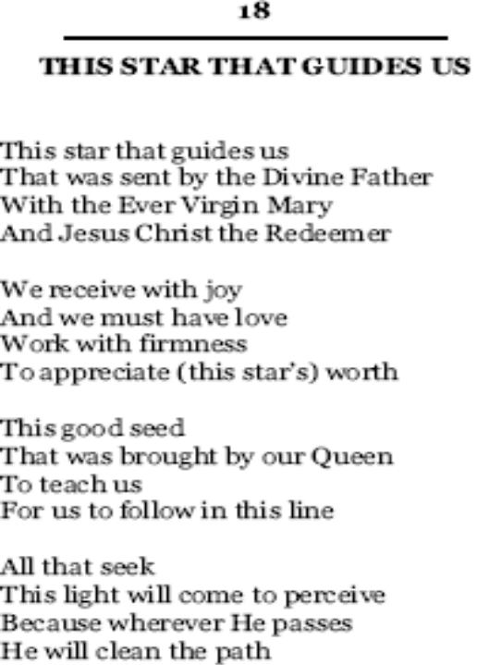
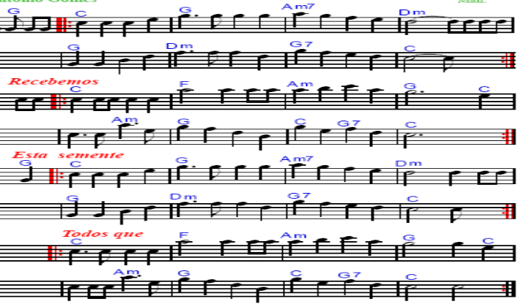
In Am:
In Cm:
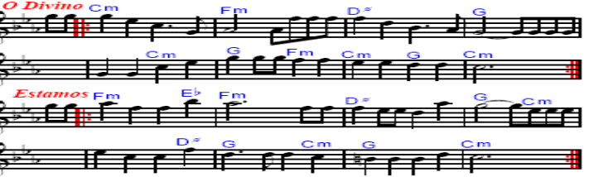
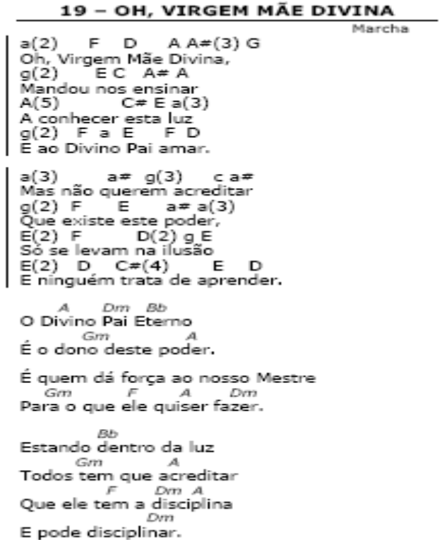→→
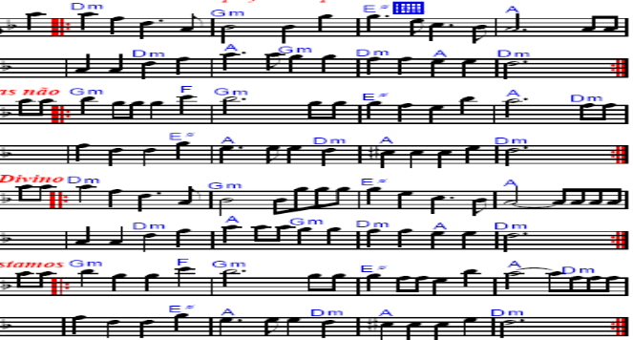

In Am:
In Cm:
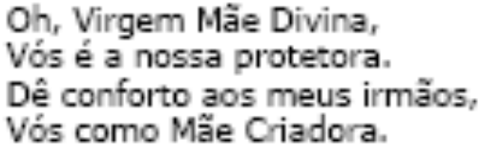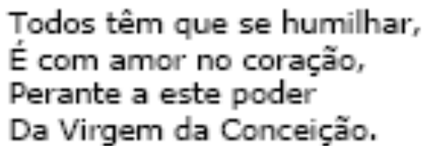

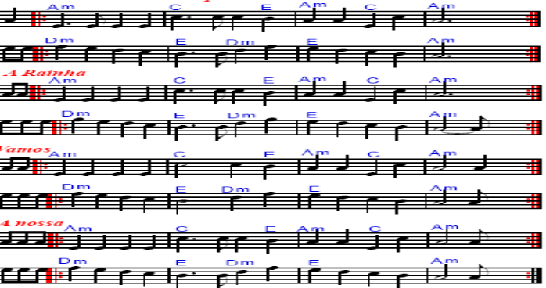

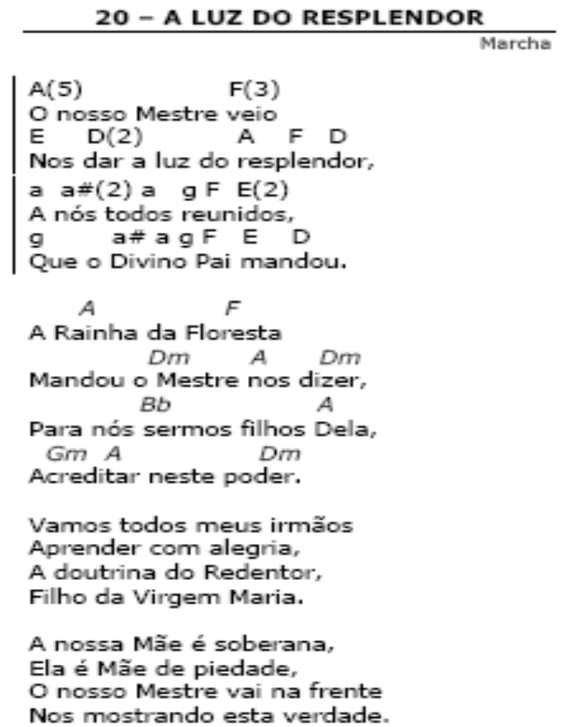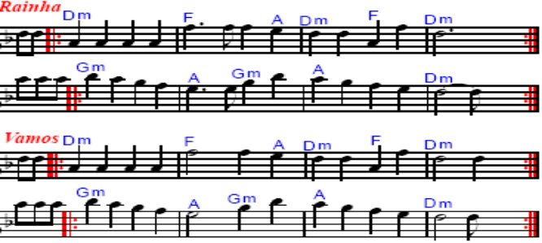
→→→
In Am:
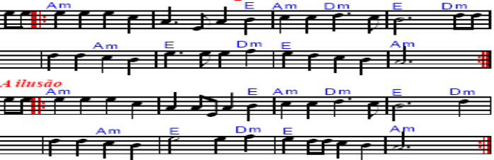
In Cm:
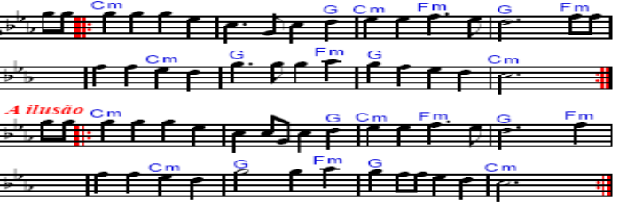
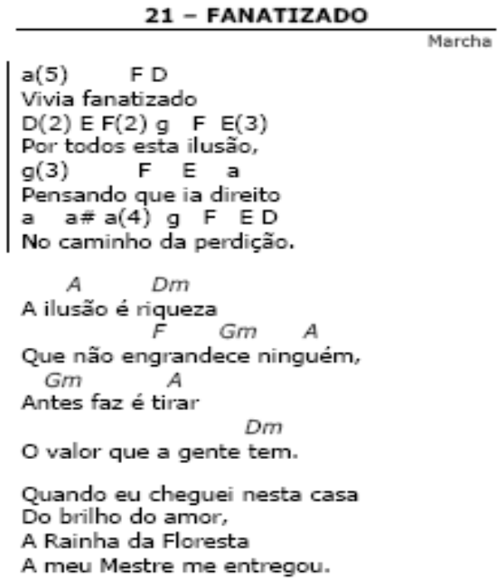→→→

In Am:
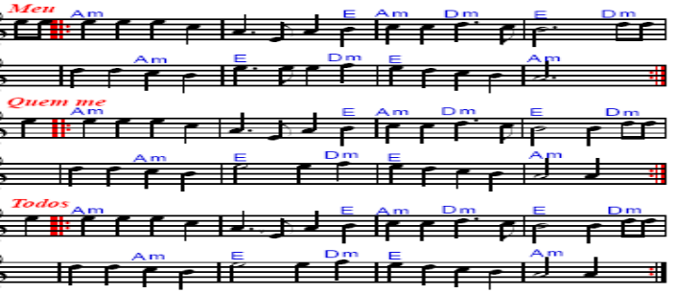
In Cm:
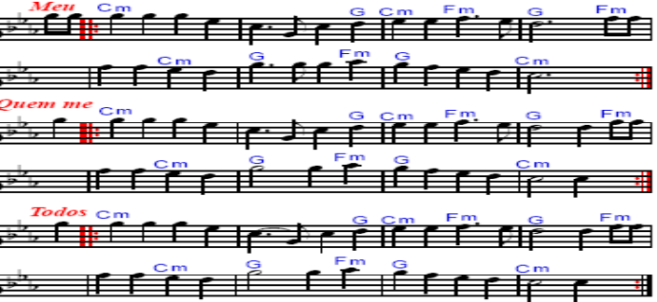
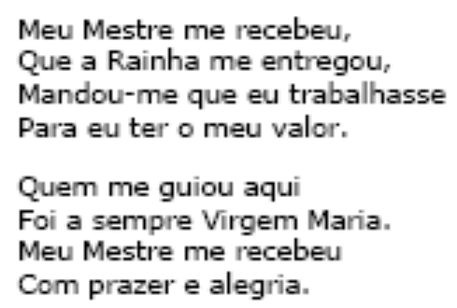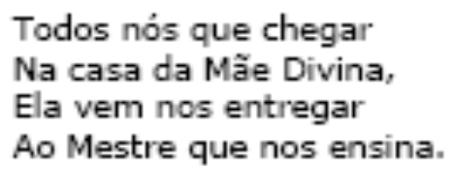

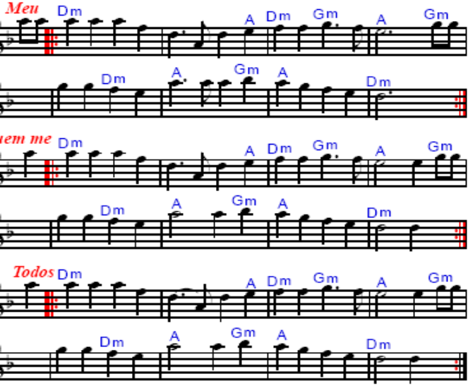

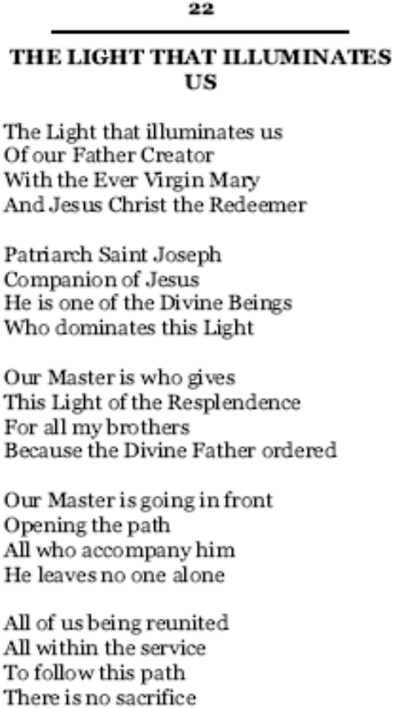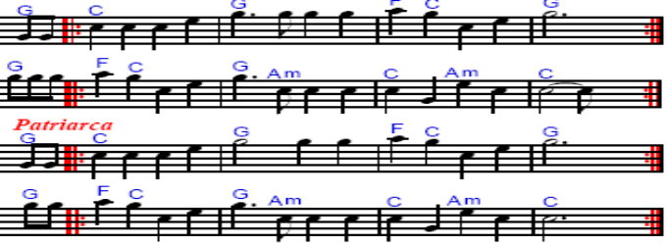
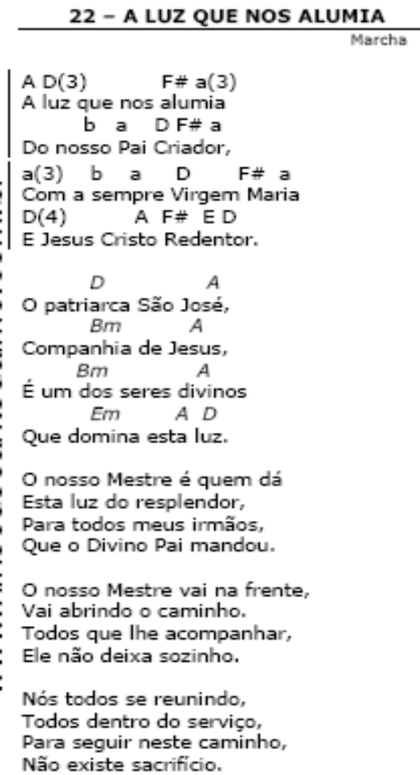
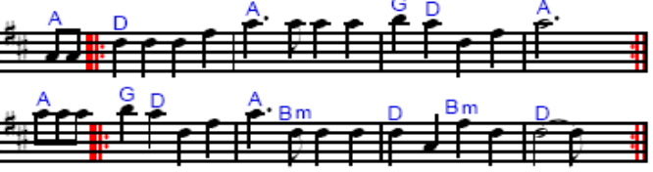
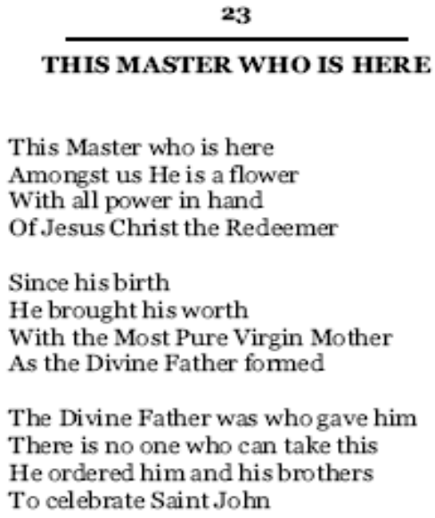→→→
In Am:
In Cm:
→→→
In Am:
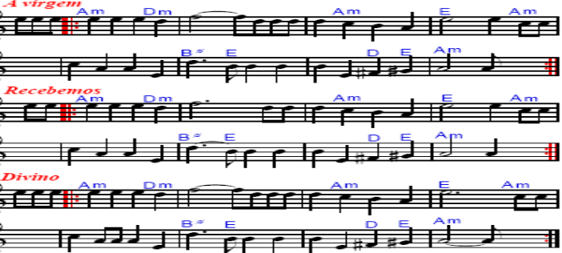
In Cm:
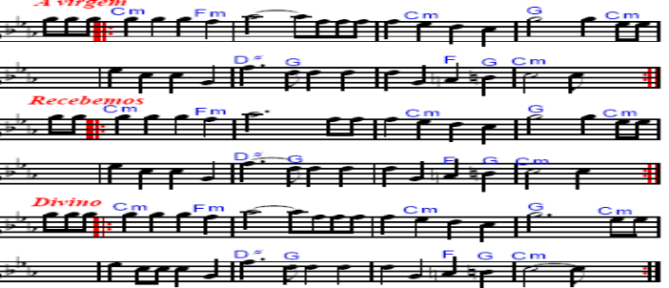
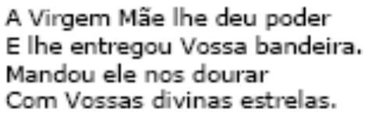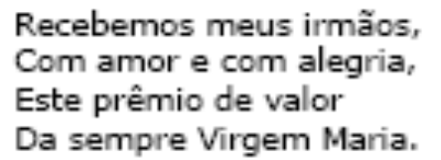

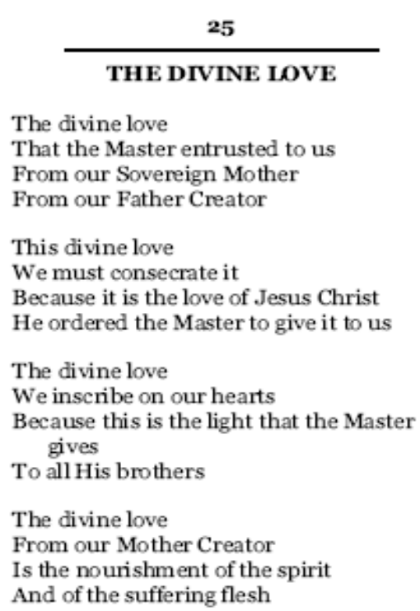

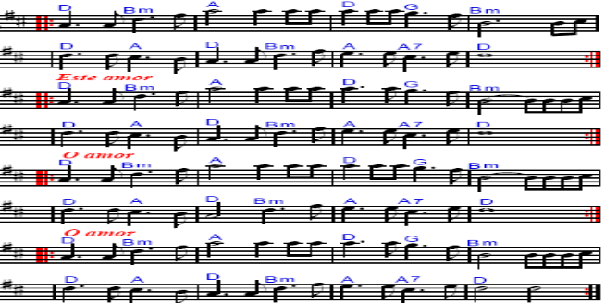
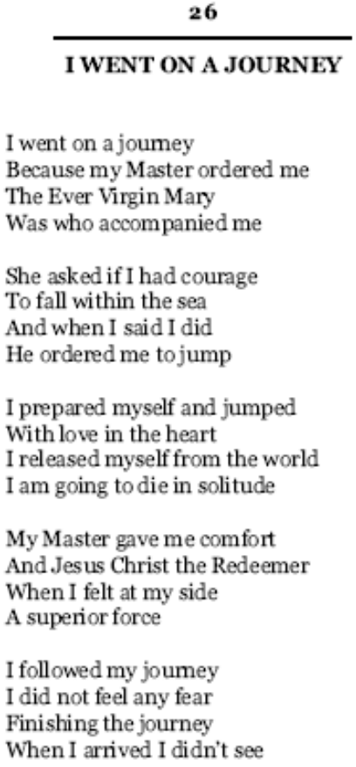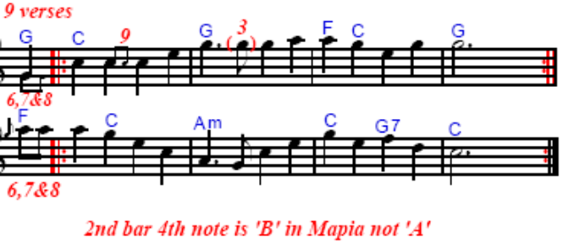
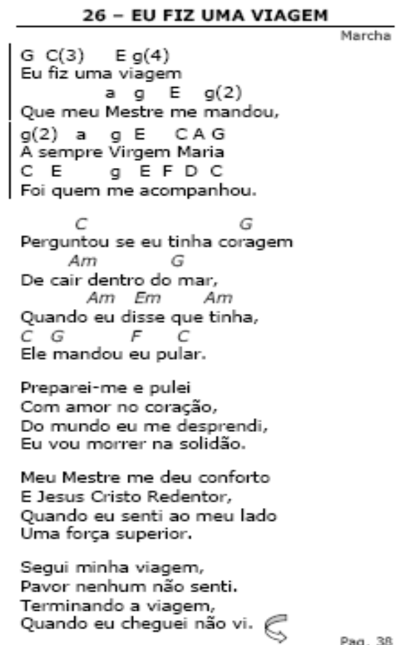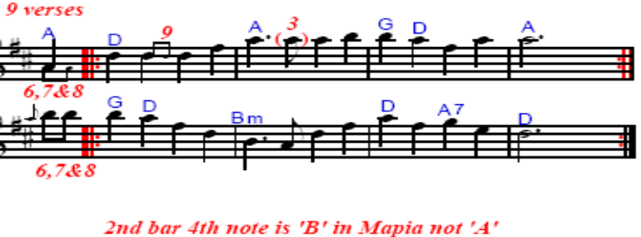


In G:
In A:
STAND
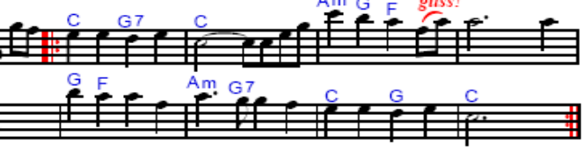
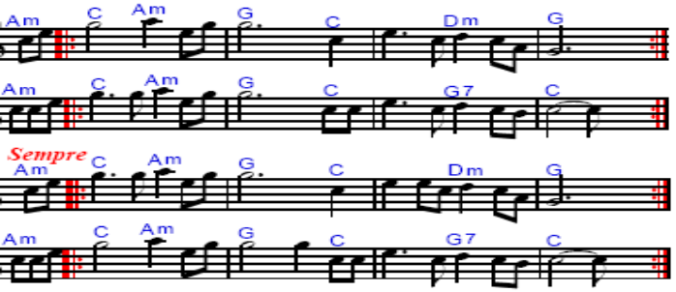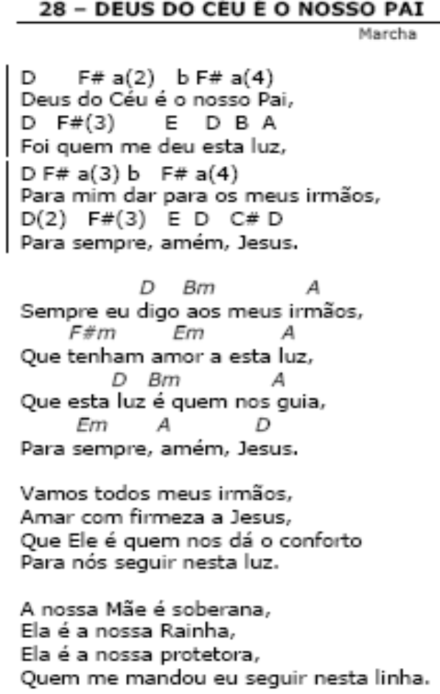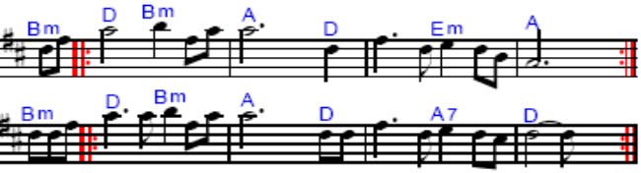
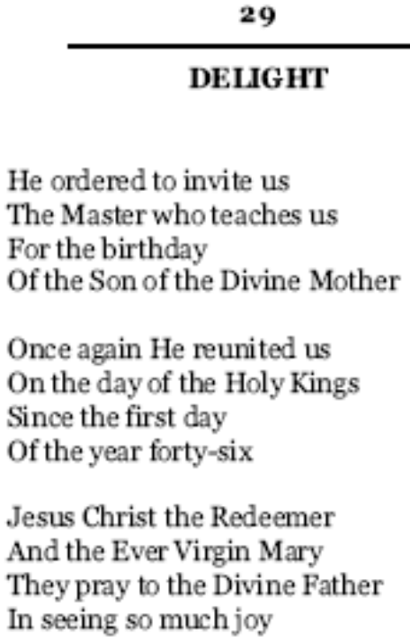→→→
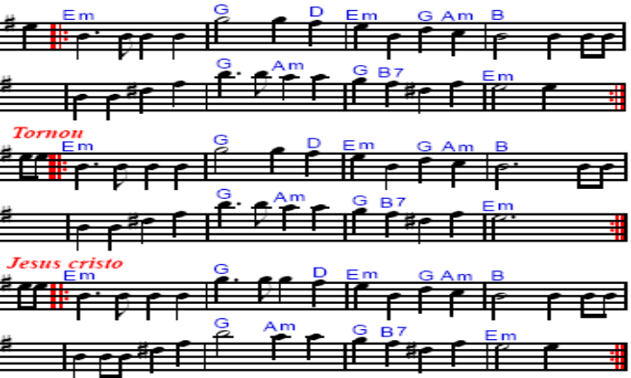
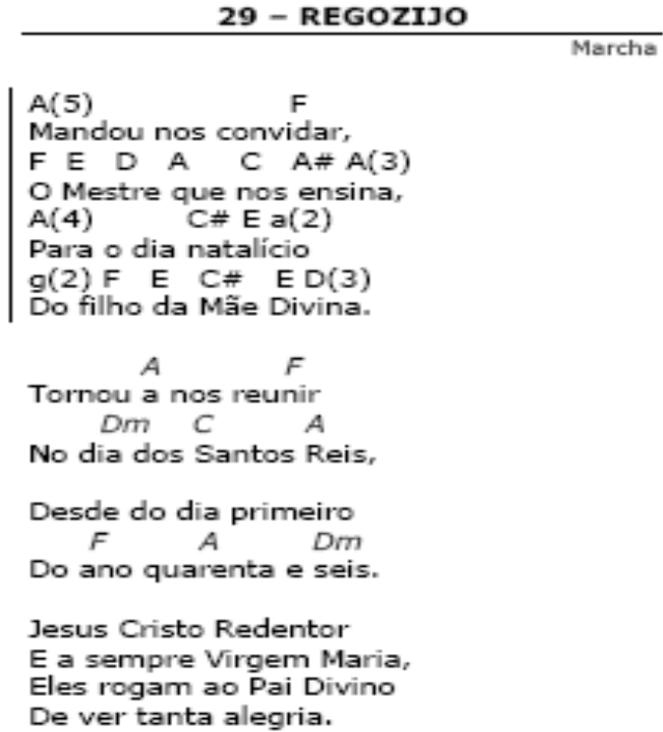→→→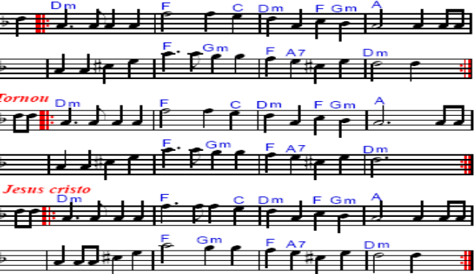

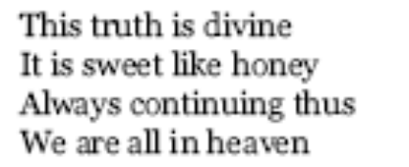
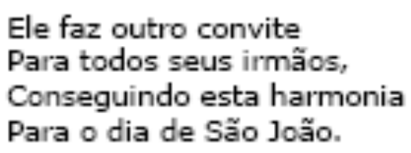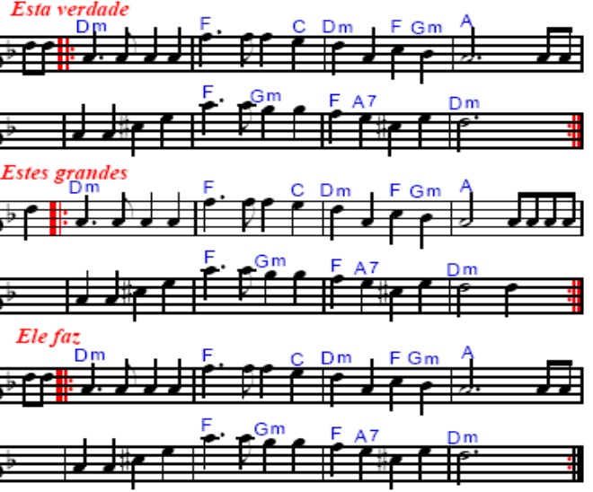

In Am:

In Cm:
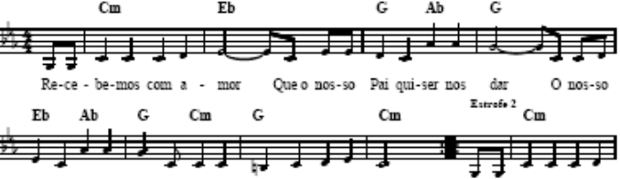
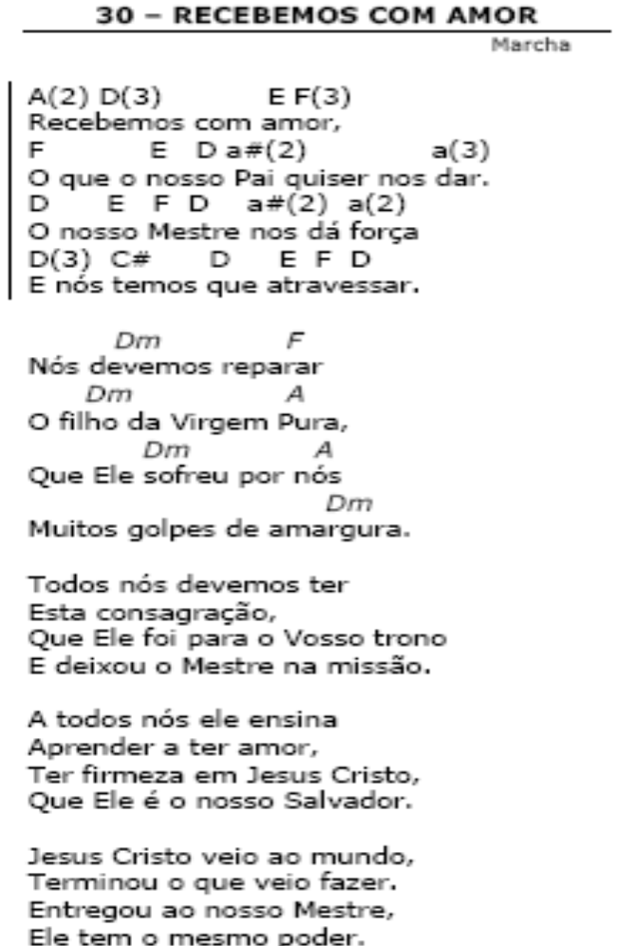
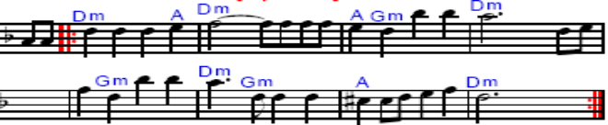
In Bm:
In Dm:
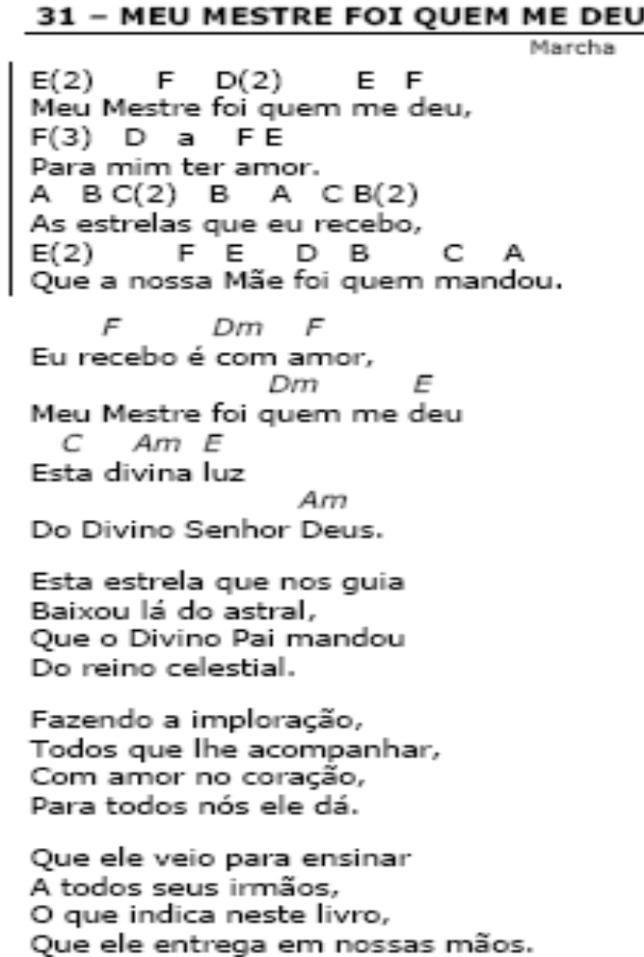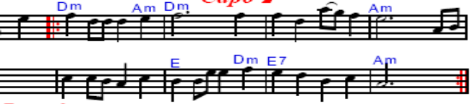
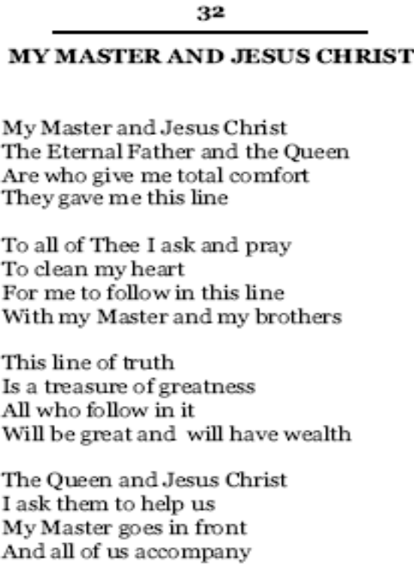
In A:
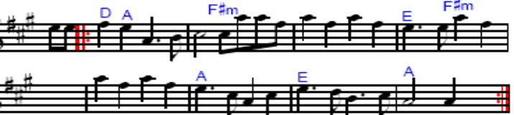
In G:
→→→
In G:
In A:
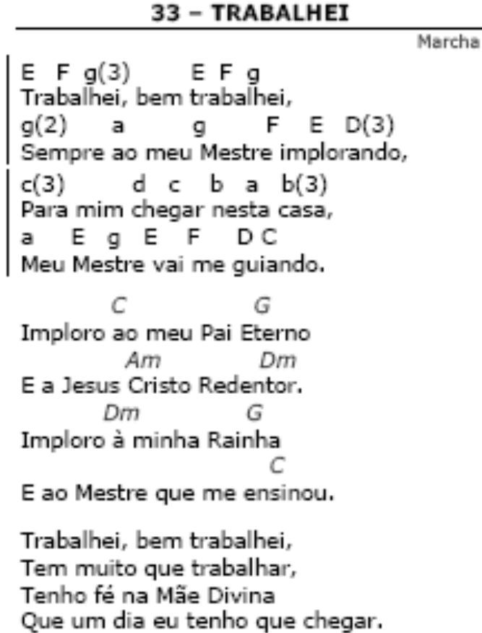
→→→
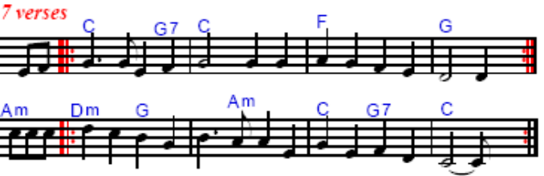

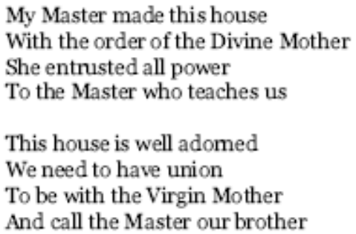
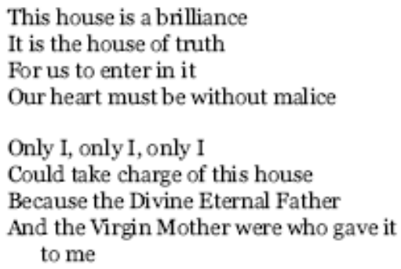
In G:
In A:
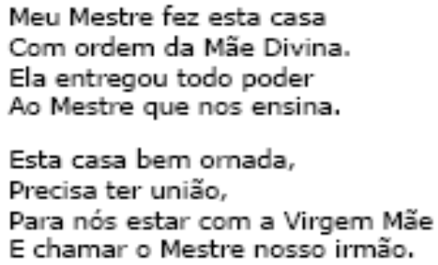

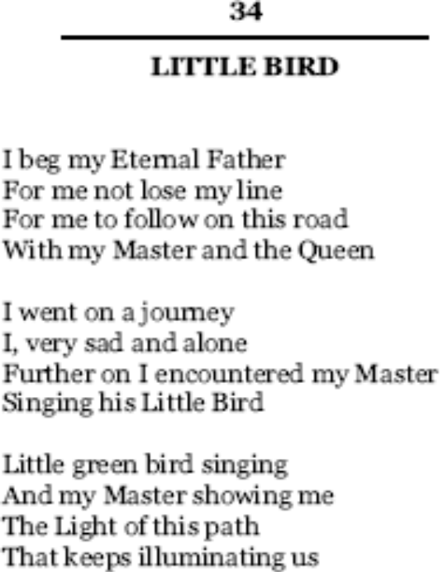→
→→→
→→→

→→→

→→→

→→→

In Am:
In Cm:





